Contents

Version Control: 3

1. Screen ID: DSC4PVR 4

2. Screen ID: DSBPDFR 7

3. Screen ID: DIBHDFR 10

4. Screen ID: DIMPDFR 12

5. Screen ID: DSDZETR 14

6. Screen ID: Y2VLLSR (SYNON Screen) 16

7. Screen ID: DSHOSRR 18

8. Screen ID: DSFMETR 20

9. Screen ID: DSARSRR 23

10. Screen ID: DSWXDFR 25

11. Screen ID: DSB7SRR 27

12. Screen ID: DSK6EFR 29

13. Screen ID: DIRLSRR 31

14. Screen ID: DSEBETR 33

15. Screen ID: DSQJSRR 36

16. Screen ID: DIQXDFR 38

17. Screen ID: DSM7DFR 40

18. Screen ID: DSM0DFR 43

19. Screen ID: CCKFPVR 45

20. Screen ID: CCLVD1R 47

21. Screen ID: DIJ5DFR 49

22. Screen ID: DSC7D1R 51

23. Screen ID: DSCADFR 54

24. Screen ID: DSIME1R 56

25. Screen ID: DIMLDFR 59

26. Screen ID: DIOQD1I 61

27. Screen ID: DSNJDTR 63

28. Screen ID: DIQADFR 65

29. Screen ID: DST1DFR 67

30. Screen ID: DSHFETR 69

31. Screen ID: DSRBDFR 71

32. Screen ID: DSQ0E1R 73

33. Screen ID: DSCZE1R 75

34. Screen ID: DIO2PVR 77

35. Screen ID: DIMMPVR 78

36. Screen ID: DSB9E1R 79

37. Screen ID: DIJVPVR 82

38. Screen ID: CCCMPVI 84

39. Screen ID: CAB6D1R 86

40. Screen ID: DSVFDFR 88

41. Screen ID: DSU5DTR 90

42. Screen ID: CCJ0PVR 92

43. Screen ID: CCHXE1R 94

44. Screen ID: DSM1DFR 97

45. Screen ID: DIG2DFR 98

46. Screen ID: DIGFE1R 99

47. Screen ID: CCGIDFI 102

48. Screen ID: CCGCD1I 103

49. Screen ID: DSGQPVI 105

# Version Control:

|  |  |  |
| --- | --- | --- |
| **Version No.** | **Description/Change description** | **Date** |
| 1.0 | Initial Version | 01-Mar-2016 |

# Screen ID: DSC4PVR

**Screen Name:** Customer Selection Screen - CU: PMT Customer Prompt & validate record - Customer Selection Screen

**AS/400 Screen shot:**

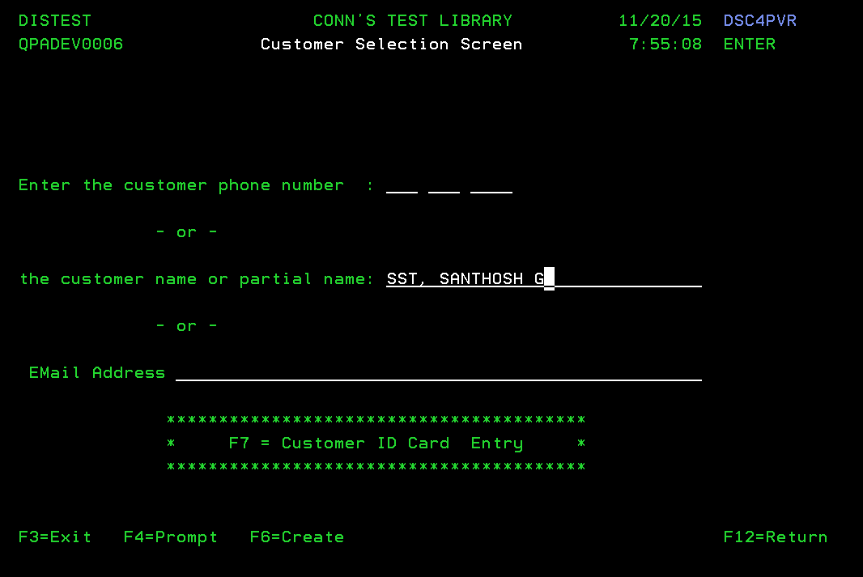

**Modernized UI:**

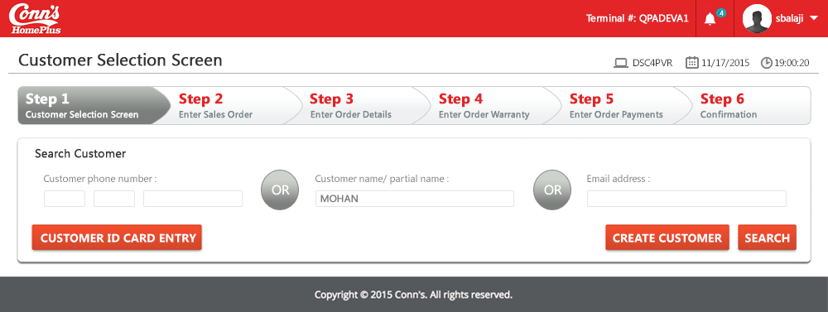

**Landing/ Entry points**

|  |  |  |  |  |
| --- | --- | --- | --- | --- |
| **Sl. No.** | **From Screen** | **Action** | **Parameters passed to this page** | **On load validations, Data Fetches** |
|  | Menu option | Menu selection | NA | NA |

**Function Keys**

| **Sl. No.** | **Function Key** | **Column name (if applicable)** | **Goes to screen ID** | **Validation before going to another screen** |
| --- | --- | --- | --- | --- |
|  | F4=Prompt | Customer Phone Number | Not Available on this column |  |
|  | F4=Prompt | Customer Name | Not Available on this column |  |
|  | F4=Prompt | Email Address | Not Available on this column |  |
|  | F6=Create | NA | Prompt to Find Customer - CCCMPVI |  |
|  | F7=Customer ID Card Entry | NA | TBD | TBD |
|  | F3=Exit | NA | Menu options | NA |
|  | F12=Return | NA | Menu options | NA |
|  | Enter Key | NA |  | When the user press “Enter” key without entering any search string, an error message is thrown  Error Message: “Name or phone number required to continue “ |

**List of Fields**

|  |  |  |  |  |
| --- | --- | --- | --- | --- |
| **Sl. No.** | **Column name** | **Tab Order** | **Validation** | **Backend Validation** |
|  | Enter the customer phone number  (3 sections like xxx-xxx-xxxx) | 1 The cursor by default would be on the 1st part of the phone number  2 On the 2nd hit, the cursor moves to the next part of phone number  3 On the 3rd hit of tab, the last part of phone number will have the cursor | Should be able to type only numeric values  All 10 digits should be filled | 1) DSABCPP -Customer Master- a. ABALTX – Customer Name b. ABABST -Customer Type. 2) DSJLCPP - Customer phone number. A.JLZTNB - Phone number (Home, business and Cell. It is depends upon JLPACD phone type.) |
|  | Customer Name | 4 | Should be able to type any of the combinations | 1) DSABCPP -Customer Master- a. ABALTX – Customer Name b. ABALNB – Customer ID c. ABABST -Customer Type. |
|  | Email Address | 5 | Should be able to type any characters in the field. But the results should be displayed only if the entire email ID matches  Customer Name Customer Phone number | 1)DIEJCPP - Customer Email ID. a. EJGVXT - Email ID |

# Screen ID: DSBPDFR

**Screen Name**: Display Customer – CU: DSP Customer Display file - Display customer

**AS/400 Screen shot:**

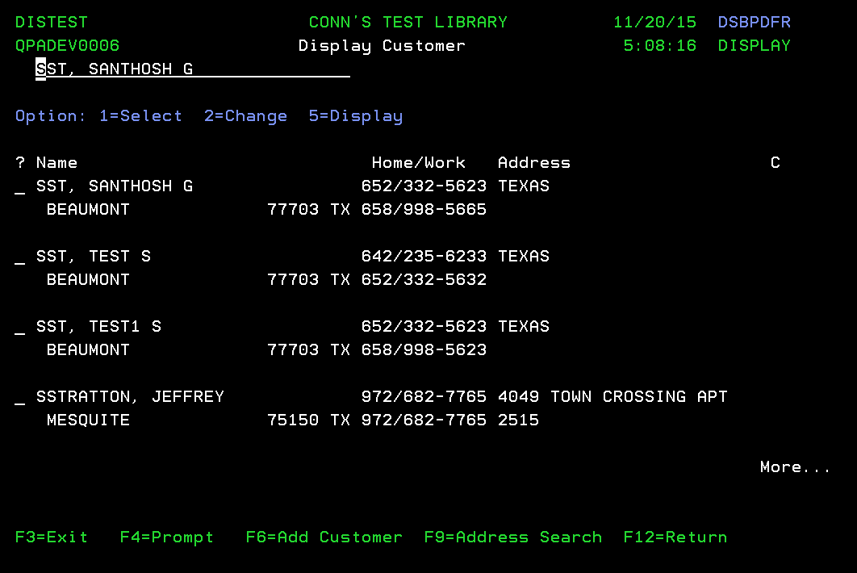

**Modernized UI:**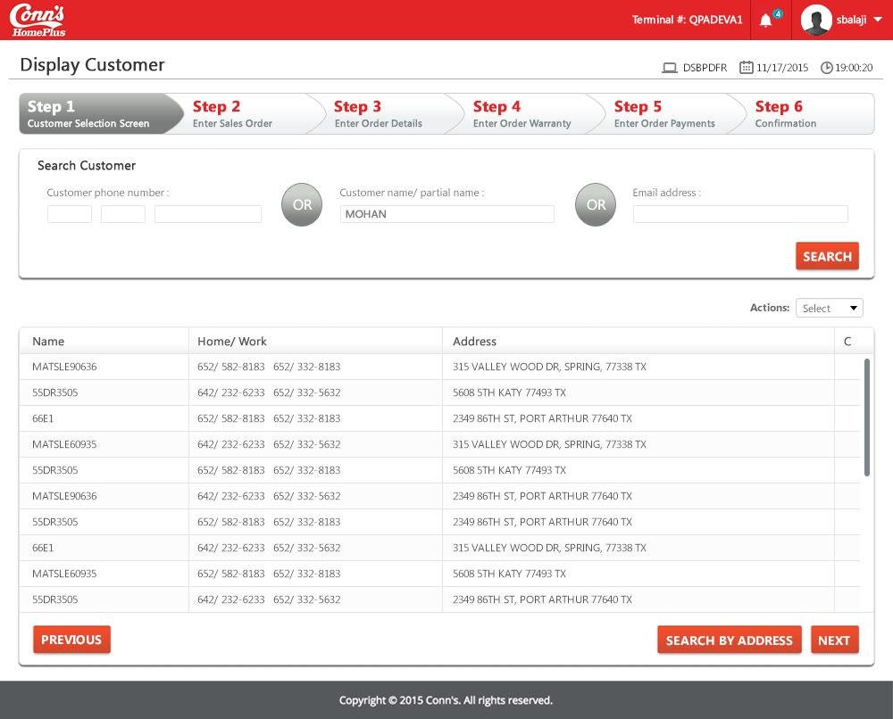

**Landing/ Entry points**

|  |  |  |  |  |  |
| --- | --- | --- | --- | --- | --- |
| **Sl. No.** | **From Screen** | **Action** | **Parameters passed to this page** | **On load validations** | **Data Fetches** |
|  | DSC4PVR | Press “Enter” key after entering the search string | Search string entered | The names that match the most with the given search string should be on top | 1) DSABCPP -Customer Master- a. ABALTX – Customer Name b. ABALNB – Customer ID c. ABABST -Customer Type. 2) DSJLCPP - Customer phone number. A.JLZTNB - Phone number (Home, business and Cell. It is depends upon JLPACD phone type.) 3) DSACCPP - a.ACAPTX - Zip code b.ACANTX - Address Line1 c.ACAOTX - Address Line2 4) DSAEREP a.AEAPTX - Zip Code b.AEADST - State c.AEAQTX - City d.AEARTX - Country |

**Function Keys**

|  |  |  |  |  |
| --- | --- | --- | --- | --- |
| **Sl. No.** | **Function Key** | **Column name (if applicable)** | **Goes to screen Id** | **Validation before going to another screen** |
|  | F4=Prompt | Not available for any fields in this screen | NA | NA |
|  | F6=Add Customer | NA | Prompt to Find Customer - CCCMPVI | NA |
|  | F3=Exit | NA | Menu option | NA |
|  | F12=Return | NA | Customer Selection Screen - DSC4PVR | NA |
|  | F9=Address Search |  | Display Addresses for Customers - DIQADFR | NA |
|  | Enter Key | NA | The customers without names would be displayed | NA |
|  | 1=Select | Only in the “?” fields | Enter Sales Order Header - DSDZETR | NA |
|  | 2=Change | Only in the “?” fields | Edit Customer Details - DSIME1R | NA |
|  | 5=Display | Only in the “?” fields | Display Customer Details - DSC7D1R | NA |

**List of Fields**

|  |  |  |  |  |
| --- | --- | --- | --- | --- |
| **Sl. No.** | **Column name** | **Tab Order** | **Validation** | **Backend Validation** |
|  | Customer Name filter (Over the top) | Start | This is the search string entered by the user in the previous screen | NA |
|  | Name | NA | Information got from DB | The most matching record with the search string is displayed on top |
|  | Home/Work | NA | Numbers of the appropriate name of the customer | NA |
|  | Address | NA | Address of the appropriate name of the customer | NA |
|  | ? fields | On every hit of tab, the cursor moves to the next “?” field | Only 1,2,5 are accepted | The name, phone number(s), address are all of the same record in one row |

# Screen ID: DIBHDFR

**Screen Name**: Display Customer By Phone – CU: DSP Numbers by # Display file - Display Customer by Phone number

**AS/400 Screen shot:**

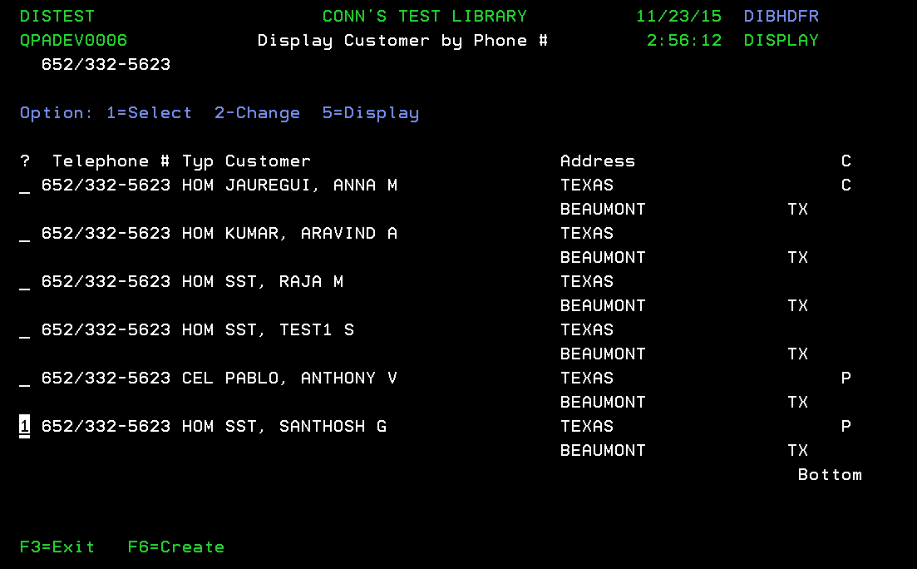

**Modernized UI:**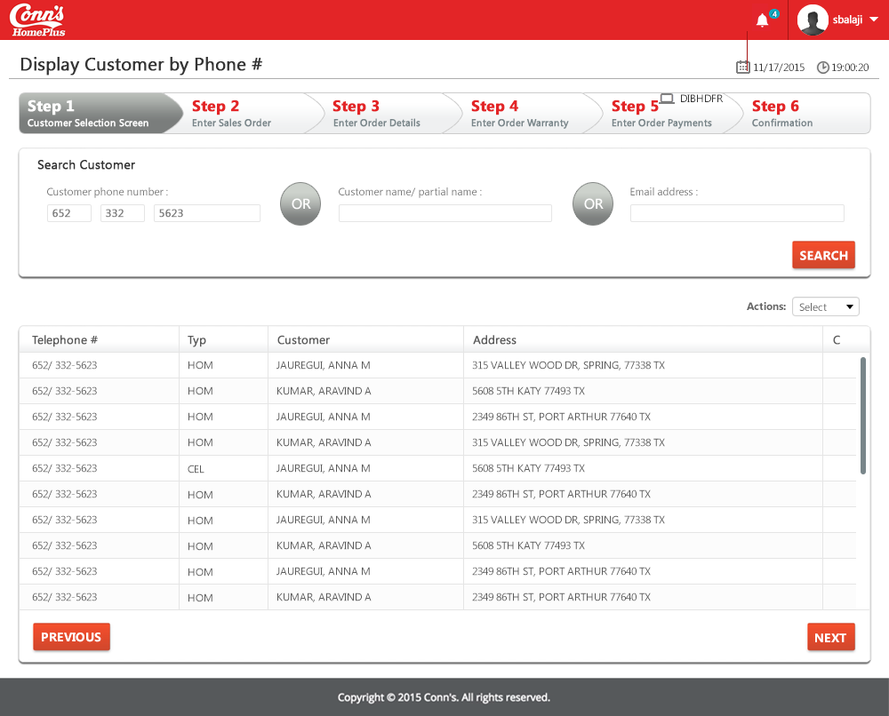

**Landing/ Entry points**

|  |  |  |  |  |
| --- | --- | --- | --- | --- |
| **Sl. No.** | **From Screen** | **Action** | **Parameters passed to this page** | **On load validations, Data Fetches** |
| 1 | Customer Selection Screen - DSC4PVR | Hit on enter key after entering the phone number | Search string entered in the previous screen | The most matching record with the search string is displayed on top  1) DSABCPP -Customer Master- a. ABALTX – Customer Name b. ABALNB – Customer ID c. ABABST -Customer Type. 2) DSJLCPP - Customer phone number. A.JLZTNB - Phone number (Home, business and Cell. It is depends upon JLPACD phone type.) 3) DSACCPP - a.ACAPTX - Zip code b.ACANTX - Address Line1 c.ACAOTX - Address Line2 4) DSAEREP a.AEAPTX - Zip Code b.AEADST - State c.AEAQTX - City d.AEARTX - Country |

**Function Keys**

| **Sl. No.** | **Function Key** | **Column name (if applicable)** | **Goes to screen Id** | **Validation before going to another screen** |
| --- | --- | --- | --- | --- |
| 1 | F4=Prompt | Not available for any fields in this screen | NA | NA |
| 2 | F6=Create | NA | Prompt to Find Customer - CCCMPVI | NA |
| 3 | F3=Exit | NA | Customer Selection Screen - DSC4PVR | NA |
| 4 | F12=Return | NA | Customer Selection Screen - DSC4PVR | NA |
| 5 | Enter Key | NA | Nothing happens | NA |
| 7 | 1=Select | Only in the “?” fields | Enter Sales Order Header - DSDZETR | NA |
| 8 | 2=Change | Only in the “?” fields | Edit Customer Details - DSIME1R | NA |
| 9 | 5=Display | Only in the “?” fields | Display Customer Details - DSC7D1R | NA |

**List of Fields**

-- None --

# Screen ID: DIMPDFR

**Screen Name**: Display Customer By Email – CU: DSP Matching Emails Display file - Display Matching emails

**AS/400 Screen shot:**

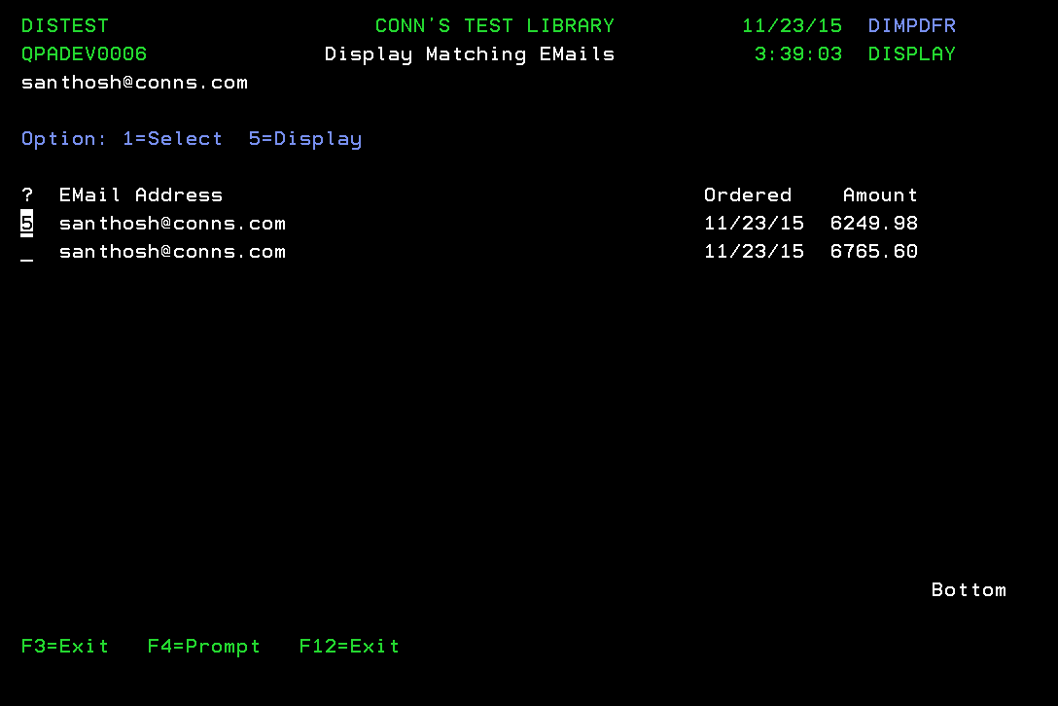

**Modernized UI:**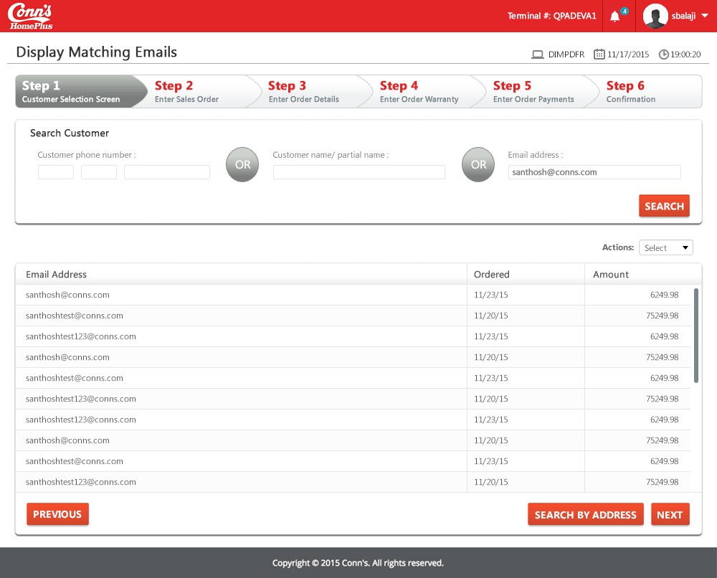

**Landing/ Entry points**

|  |  |  |  |  |
| --- | --- | --- | --- | --- |
| **Sl. No.** | **From Screen** | **Action** | **Parameters passed to this page** | **On load validations, Data Fetches** |
| 1 | Customer Selection Screen - DSC4PVR | Hit on enter key after entering the phone number | Search string entered in the previous screen | If only a single person is matched to that email ID, the person will be selected by default and “Enter Sales Order Header – DSDZETR” screen would appear  1) DIEJCPP – a. EJGVXT – Email Address b. EJALNB – Customer ID. 2) DSA7CPP - a. A7AIDT – Order Date 3) DSA0CPP – a. A0AOVA Sum of all line item = amount. |

**Function Keys**

| **Sl. No.** | **Function Key** | **Column name (if applicable)** | **Goes to screen ID** | **Validation before going to another screen** |
| --- | --- | --- | --- | --- |
| 1 | F4=Prompt | Not available for any fields in this screen | NA | NA |
| 2 | F3=Exit | NA | Customer Selection Screen - DSC4PVR | NA |
| 3 | F12=Exit | NA | Customer Selection Screen - DSC4PVR | NA |
| 4 | Enter Key | NA | A confirmation prompt appears, but when nothing happens if we choose either Y or N | NA |
| 5 | 1=Select | Only in the “?” fields | Enter Sales Order Header - DSDZETR | NA |
| 6 | 5=Display | Only in the “?” fields | Display Customer Details - DSC7D1R | NA |

**List of Fields**

-- None --

# Screen ID: DSDZETR

**Screen Name**: Enter Sales Order Header – OE:ETR EntOrdHdr Edit transaction - Enter Sales Order Header

**AS/400 Screen shot:**

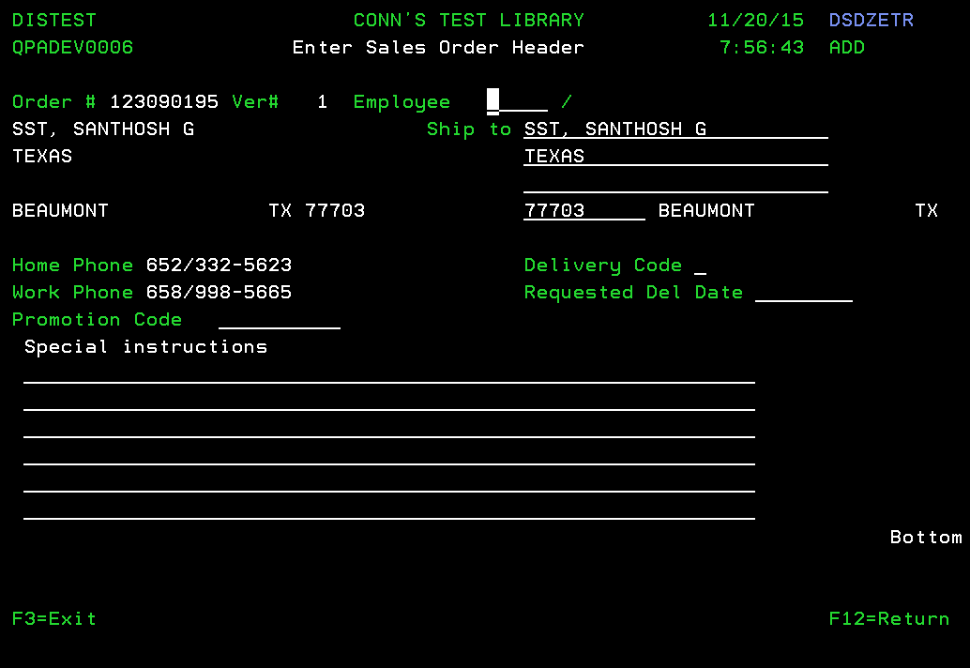

**Modernized UI:**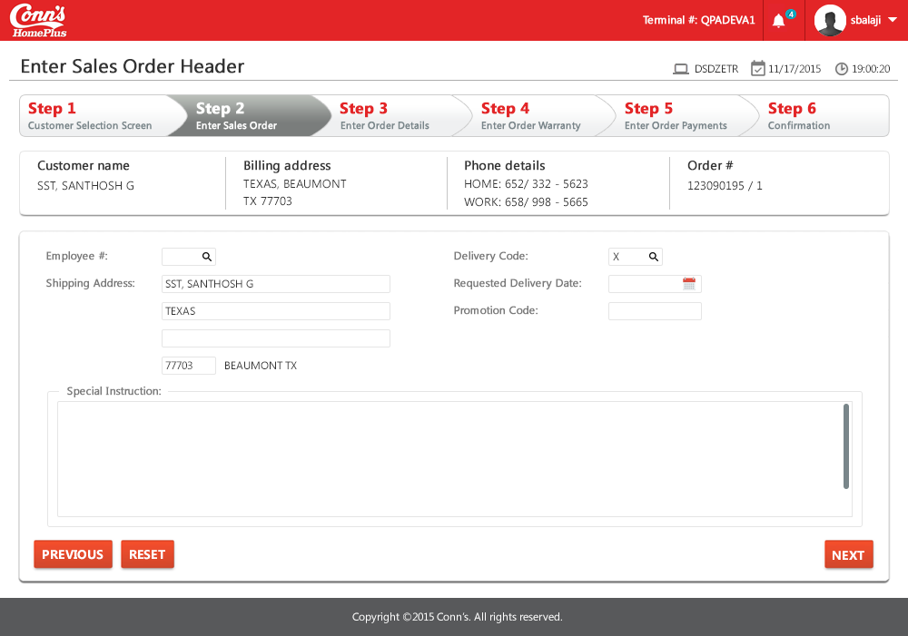

**Landing/ Entry points**

|  |  |  |  |  |
| --- | --- | --- | --- | --- |
| **Sl. No.** | **From Screen** | **Action** | **Parameters passed to this page** | **On load validations, Data Fetches** |
| 1 | Display Customer by name - DSBPDFR | Enter the search string and press “Enter” | Name, phone numbers, address of the customer | Nothing |
| 2 | Display Customer by phone no - DIBHDFR | Enter the search string and press “Enter” | Name, phone numbers, address of the customer | Nothing |
| 3 | Display Matching email - DIMPDFR | Enter the search string and press “Enter” | Name, phone numbers, address of the customer | Nothing |

**Function Keys**

| **Sl. No.** | **Function Key** | **Column name (if applicable)** | **Goes to screen ID** | **Validation before going to another screen** |
| --- | --- | --- | --- | --- |
| 1 | F4=Prompt | Does not work for “Employee” field | When we press “F4” the system does the work of “Enter” key. But “?” and “Enter” key would take us to the prompt screen (Select Salesperson – DSHOSRR) | NA |
| 2 | F3=Exit | NA | Menu option | NA |
| 3 | F12=Return | NA | Menu option | NA |
| 4 | Enter Key | NA | Without filling Employee ID, ship to address and Delivery Code the user cannot move to next screen even if Enter key is hit | Error message when the mandatory fields are empty: “Salesperson ID is required” |
| 5 | F4=Prompt | Works for” Delivery Code” | Display Allowed Values - Y2VLLSR |  |

**List of Fields**

-- None --

# Screen ID: Y2VLLSR (SYNON Screen)

**Screen Name**: Display Allowed Values – CU: YAPPOBJ Values list name search program - Display Allowed Values

**AS/400 Screen shot:**

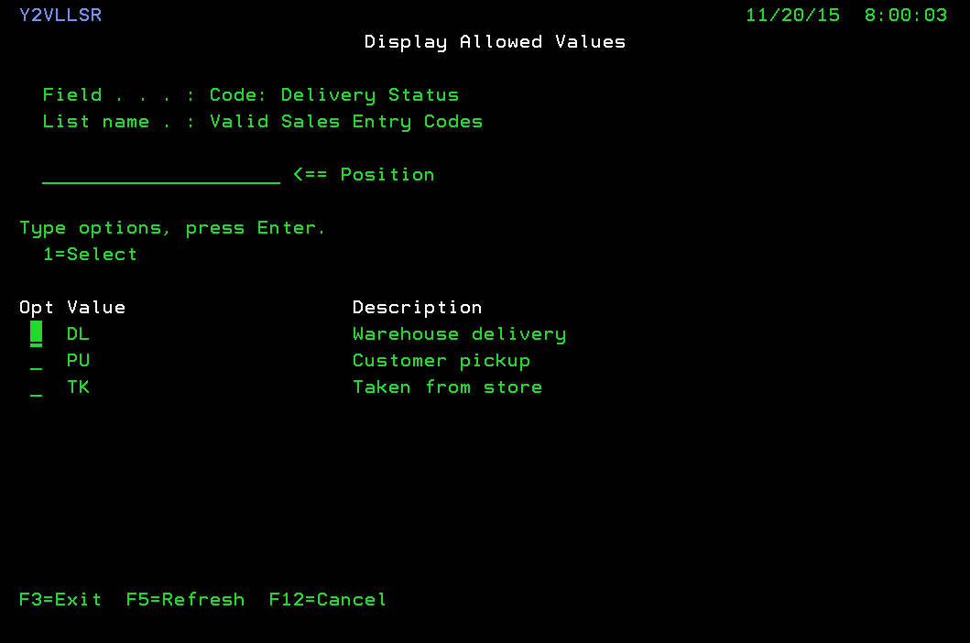

**Modernized UI:**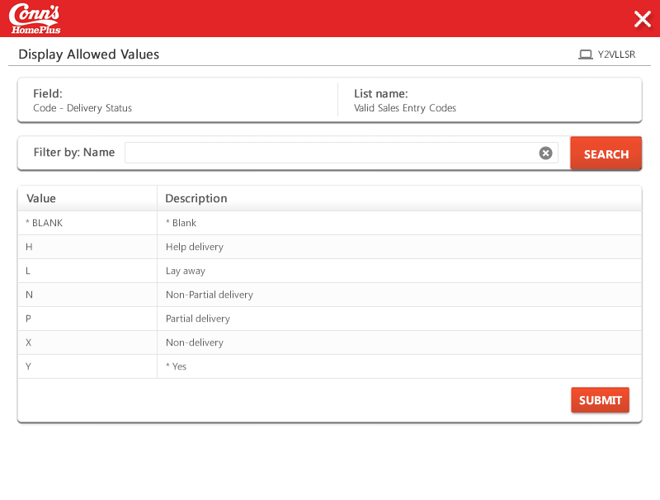

**Landing/ Entry points**

|  |  |  |  |  |
| --- | --- | --- | --- | --- |
| Sl. No. | From Screen | Action | Parameters passed to this page | On load validations, Data Fetches |
|  |  |  |  | The file name for Delivery code is DISTDBF/Y2VLLSL0. Query this file with the condition Y2EXVL = ‘Code: Delivery’, Y2CNTX = ‘*ALL values' and get the value of the column Y2LSNO (List number - 1120358).  And then query the file Y2VLLSP using the condition @@CND = 1120358(List number from the previous query) and CNDTYP = ‘VAL’ |
|  |  |  |  |  |

**Function Keys**

| Sl. No. | Function Key | Column name (if applicable) | Goes to screen Id | Validation before going to another screen |
| --- | --- | --- | --- | --- |
|  | F4=Prompt | NA |  |  |
|  | F3=Exit | NA |  | NA |
|  | F12=Cancel | NA |  | NA |
|  | Enter Key | NA |  |  |

**List of Fields**

-- None --

# Screen ID: DSHOSRR

**Screen Name**: Select Sales Person

**AS/400 Screen shot:**

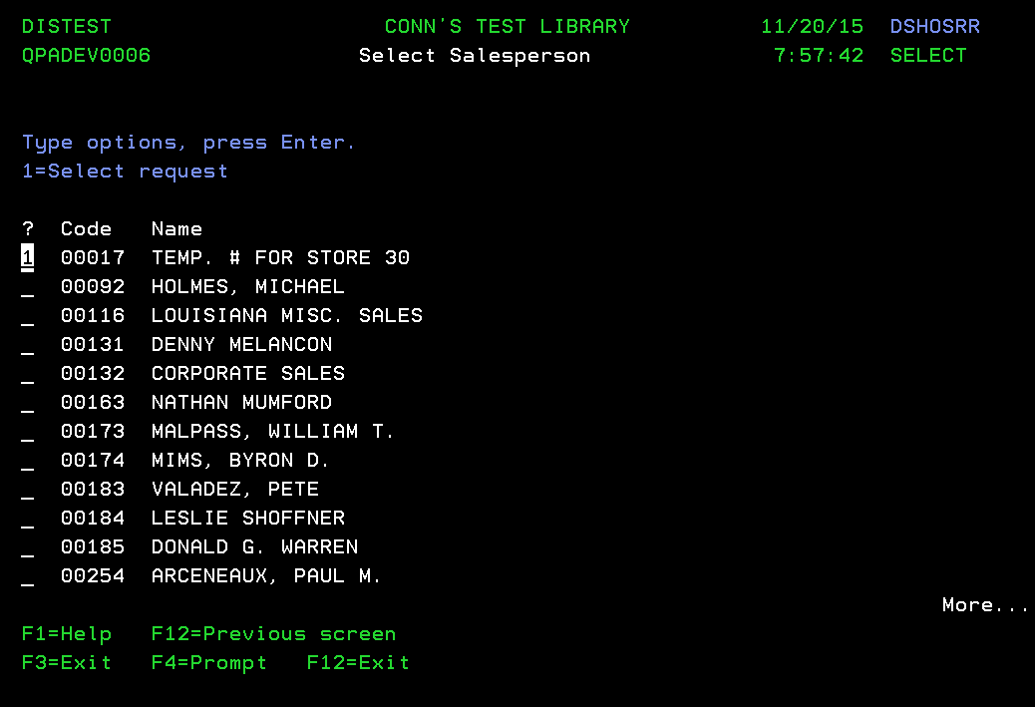

**Modernized UI:**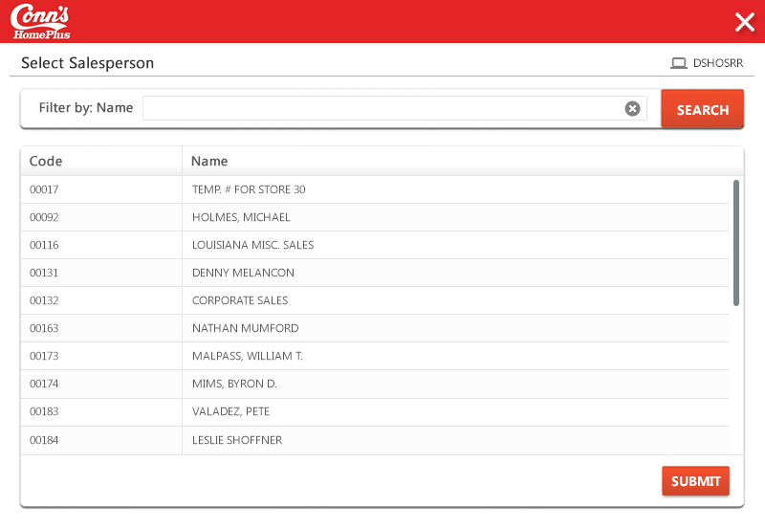

**Landing/ Entry points**

|  |  |  |  |  |
| --- | --- | --- | --- | --- |
| **Sl. No.** | **From Screen** | **Action** | **Parameters passed to this page** | **On load validations, Data Fetches** |
| 1 | Enter Sales Order Header - DSDZETR | Type “?” and press enter key in the “Employee ID” field | NA | 1) DSAPREP - a.APANST = 'SLS' b.APAJCD - Employee c. APA0TX - Employee Name |

**Function Keys**

|  |  |  |  |  |
| --- | --- | --- | --- | --- |
| **Sl. No.** | **Function Key** | **Column name (if applicable)** | **Goes to screen ID** | **Validation before going to another screen** |
| 1 | F4=Prompt | NA | Error message - Prompt not valid for this field | NA |
| 2 | F3=Exit | NA | Enter Sales Order Header - DSDZETR | NA |
| 3 | F12=Previous Screen | NA | Enter Sales Order Header - DSDZETR | NA |
| 4 | F1=Help | TBD | TBD | TBD |
| 5 | 1=Select | ? fields | Enter Sales Order Header - DSDZETR | NA |

# Screen ID: DSFMETR

**Screen Name**: Enter Order Details

**AS/400 Screen shot:**

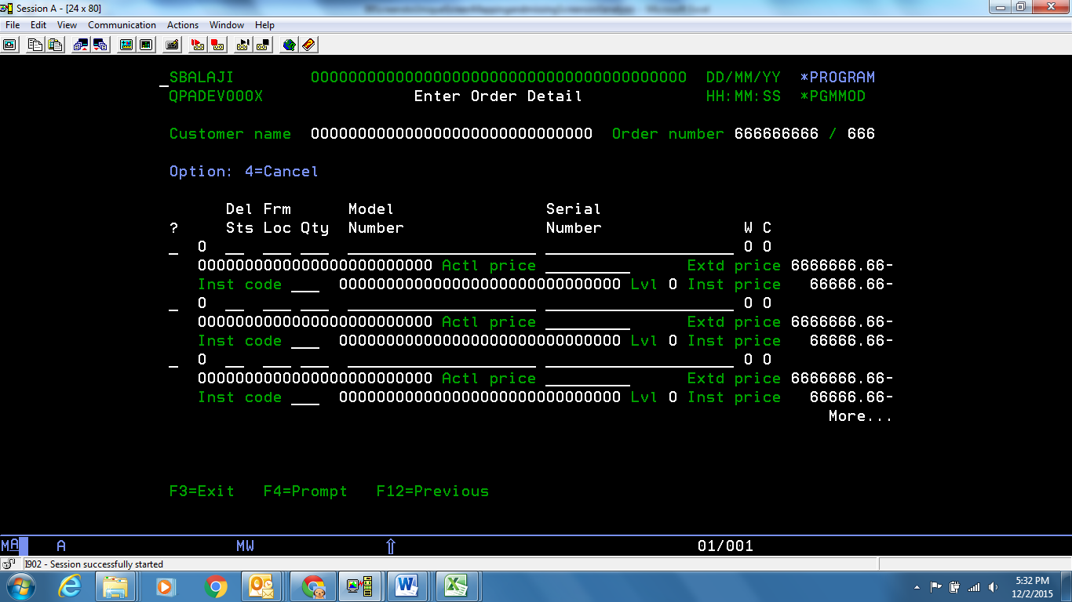

**Modernized UI:**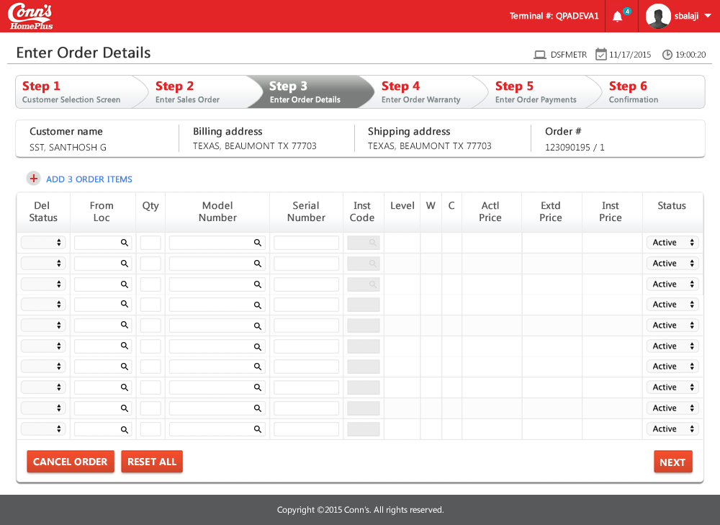

**Landing/ Entry points**

|  |  |  |  |  |
| --- | --- | --- | --- | --- |
| **Sl. No.** | **From Screen** | **Action** | **Parameters passed to this page** | **On load validations, Data Fetches** |
| 1 | Enter Sales Order Header - DSDZETR | Enter the employee ID and Delivery code and hit enter | Customer Name and Order Number (Hidden parameters: Shipping address, Billing address) | 1) DSA7CPP - a. A7BANB - Order number b.A7EXNB -Ver# c.A7ALNB-Cutomer ID 2)DSABCPP - a.ABALTX - Customer name. 3) DSA0CPP - a.A0BANB - Order number b.A0AZNB - Line number c.A0AIST - Delivery status d. A0A1NB - Quantity e.A0AACD - Location f.A0AIST - Delivery status g. A0AXTX - Model number. H. A0A8TX - Serial number.i. A0AMVA - Actual Price. J. A0AMVA - Extended Price. K. A0AECD - Installation Code. 4) DSAXREP - a.AXAXTX - Model number b.AXA2TX – Description |

**Function Keys**

|  |  |  |  |  |
| --- | --- | --- | --- | --- |
| **Sl. No.** | **Function Key** | **Column name (if applicable)** | **Goes to screen ID** | **Validation before going to another screen** |
| 1 | F4=Prompt | Del Status | Display Allowed Values(DS) - Y2VLLSR | NA |
| 2 | F4=Prompt | Frm Loc | Select Location - DSARSRR | NA |
| 6 | F4=Prompt | Model Number | Error - Prompt not valid for this field. But “?” and “enter” key will go to the Model Inquiry - DSWXDFR screen, to which “?” will be passed as a search string | NA |
| 7 | F3=Exit | NA | Menu option | NA |
| 8 | F12=Previous | NA | Enter Sales Order Header - DSDZETR | NA |
| 9 | Enter Key | NA | Enter Order Payments - DSEBETR | NA |
| 10 | 4=Cancel | Once we enter some model number, delivery status, location, quantity, serial number and hit enter, a confirmation will be asked. When N(No) is pressed, enter 4 in the “?” field, and hit enter, the corresponding item will delete | NA | NA |

**List of Fields**

| **Sl. No.** | **Column name** | **Tab Order** | **Validation** | **Backend Validation** |
| --- | --- | --- | --- | --- |
|  | Del Status | 1 | Should not be blank | Only available options shall be chosen |
|  | Loc | 2 | Should not be blank | Only available options shall be chosen |
|  | Qty | 3 | Should not be blank  Enter numeric value | NA |
|  | Model Number | 4 | Should not be blank | Only available options shall be chosen |
|  | Serial Number | 5 | Should not be blank | NA |

# Screen ID: DSARSRR

**Screen Name** : Select Location

**AS/400 Screen shot:**

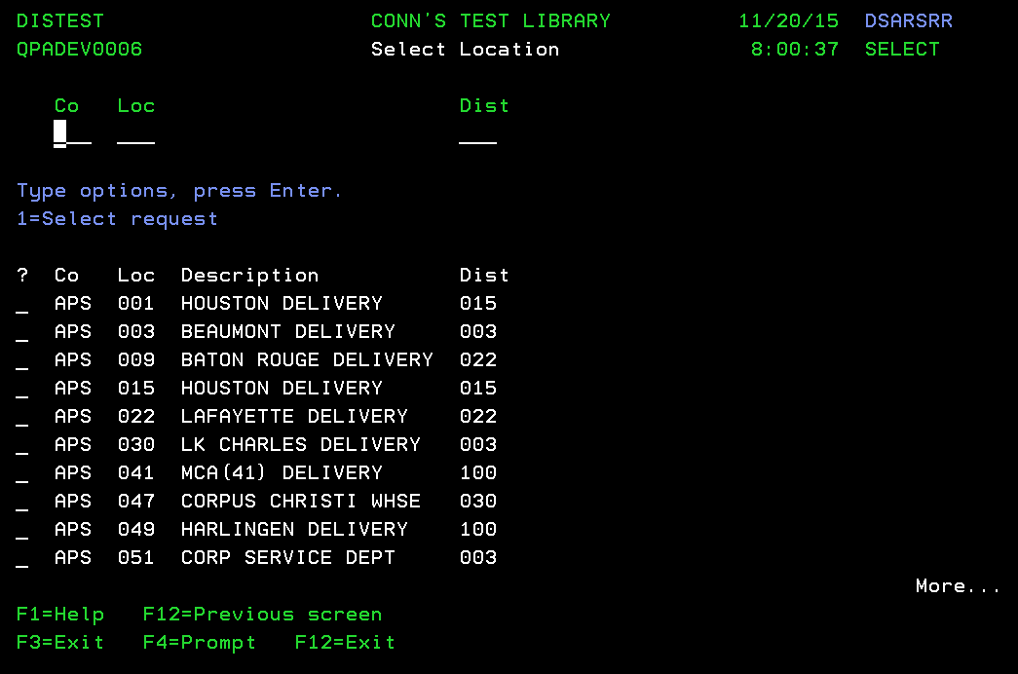

**Modernized UI:**

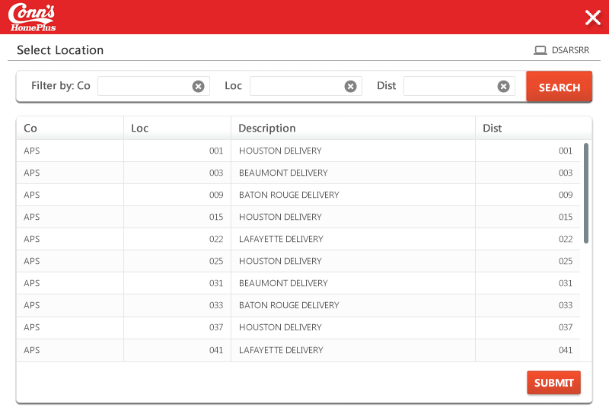

**Landing/ Entry points**

|  |  |  |  |  |
| --- | --- | --- | --- | --- |
| **Sl. No.** | **From Screen** | **Action** | **Parameters passed to this page** | **On load validations, Data Fetches** |
| 1 | Enter Order Detail - DSFMETR | Press “F4” by placing the pointer in the “Frm Loc” field | NA | 1) DSADREP - a.ADABCD - Company b.ADAACD - Location c.ADASTX – Descriptiond.ADACCD –Dist |

**Function Keys**

|  |  |  |  |  |
| --- | --- | --- | --- | --- |
| **Sl. No.** | **Function Key** | **Column name (if applicable)** | **Goes to screen ID** | **Validation before going to another screen** |
| 1 | F4=Prompt | Enter Co (Not applicable for this field) | NA | NA |
| 2 | F4=Prompt | Enter Loc (Not applicable for this field) | NA | NA |
| 3 | F4=Prompt | Enter Dist | NA | NA |
| 4 | F3=Exit | NA | Enter Order Detail - DSFMETR | NA |
| 5 | F12=Previous Screen | NA | Enter Order Detail - DSFMETR | NA |
| 6 | F1=Help | TBD | YDDSHPR0 | NA |
| 7 | Enter Key | Cannot move to any other screen without choosing an option | NA | NA |

**List of Fields**

|  |  |  |  |  |
| --- | --- | --- | --- | --- |
| **Sl. No.** | **Column name** | **Tab Order** | **Validation** | **Backend Validation** |
| 1 | Co | Start | Should not be blank | If the entered company name is not found in the DB, no results would be displayed |
| 2 | Loc | 2 | Should not be blank (like a filter) | Results thrown are based on best matching locations |
| 3 | Dist | 3 | Should not be blank (like a filter) | Exact matches would be displayed. If no matches found “No data to display” error is thrown |

# Screen ID: DSWXDFR

**Screen Name**: Model Inquiry

**AS/400 Screen shot:**

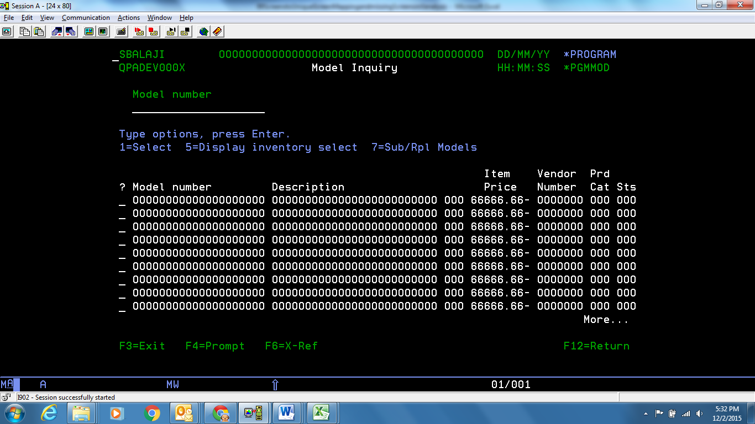

**Modernized UI:**

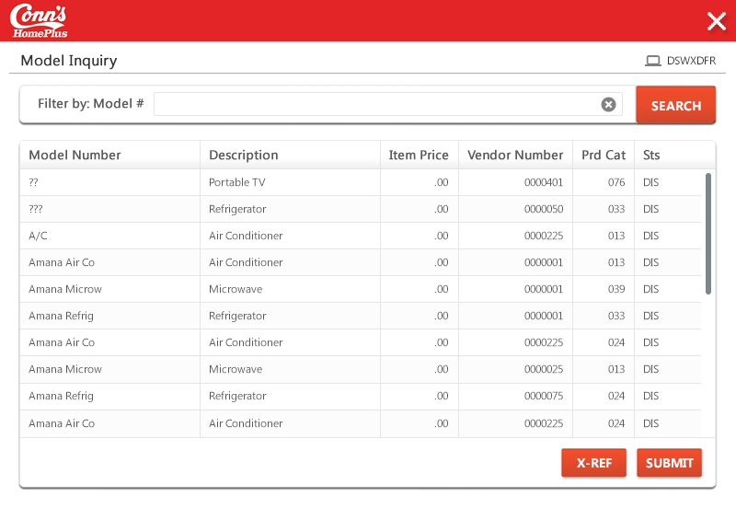

**Landing/ Entry points**

|  |  |  |  |  |
| --- | --- | --- | --- | --- |
| **Sl. No.** | **From Screen** | **Action** | **Parameters passed to this page** | **On load validations, Data Fetches** |
| 1 | Enter Order Detail - DSFMETR | Press “?” by placing the pointer in the “Model Num-ber” field, and hit “Enter” | NA | 1) DSAXREP - a.AXAXTX - Model number b.AXA2TX - Model Description c.AXBLNB - Vendor number d.AXAXCD - Prod Code e.AXAXST – Status |

**Function Keys**

|  |  |  |  |  |
| --- | --- | --- | --- | --- |
| **Sl. No.** | **Function Key** | **Column name (if applicable)** | **Goes to screen ID** | **Validation before going to another screen** |
| 1 | F4=Prompt | Model Number | Error - Prompt not valid for this field | NA |
| 2 | F6=X-Ref | NA | Stays in same screen, DSWXDFR | NA |
| 3 | F3=Exit | NA | Enter Order Detail - DSFMETR | NA |
| 4 | F12=Return | NA | Enter Order Detail - DSFMETR | NA |
| 5 | Enter Key | NA | Without entering anything in the screen, if we press “Enter”, the items that has “space” in the start of its name will be displayed at the top | NA |

**List of Fields**

|  |  |  |  |  |
| --- | --- | --- | --- | --- |
| **Sl. No.** | **Column name** | **Tab Order** | **Validation** | **Backend Validation** |
| 1 | Model Number | Start (if tab is pressed anymore, it travels through the “?” fields) | Can be blank | 1) DSAXREP - a.AXAXTX - Model number |

# Screen ID: DSB7SRR

**Screen Name**: Select Installations

**AS/400 Screen shot:**

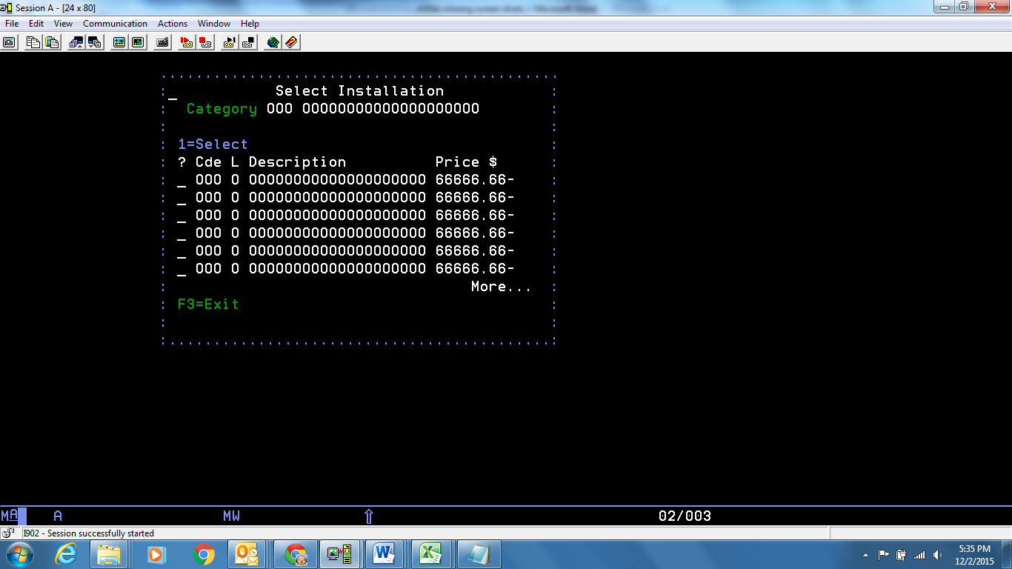

**Modernized UI:**

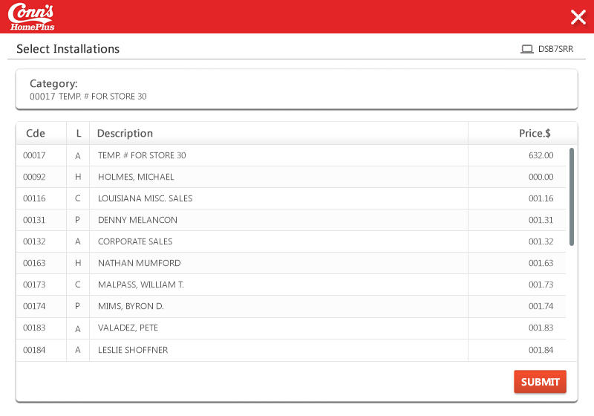

**Landing/ Entry points**

|  |  |  |  |  |
| --- | --- | --- | --- | --- |
| **Sl. No.** | **From Screen** | **Action** | **Parameters passed to this page** | **On load validations, Data Fetches** |
| 1 | Enter Order Detail - DSFMETR | Fill in the Del Sts, From Loc, Model Number, Serial Number and press “Enter” | NA | 1) DSADREP- A.ADABCD - Company b.ADAACD - Location c.ADACCD- District 2) DSAXREP - a.AXAXTX - Model number b.AXAXCD. Prod category. 3)DSBQREP - a.BQACCD - District b.BQAECD - Installation code. C.BQAJPR -Price installation. 4) DSANREP- a.ANAJST -Level b.ANAYTX – Description |

**Function Keys**

|  |  |  |  |  |
| --- | --- | --- | --- | --- |
| **Sl. No.** | **Function Key** | **Column name (if applicable)** | **Goes to screen ID** | **Validation before going to another screen** |
| 1 | F3=Exit | NA | Enter Order Detail - DSFMETR | NA |
| 2 | 1=Select | ? fields | Enter Order Detail – DSFMETR | NA |
| 3 | F12 | NA | Enter Order Detail - DSFMETR | NA |

# Screen ID: DSK6EFR

**Screen Name**: Enter Order Details Warranty

**AS/400 Screen shot:**

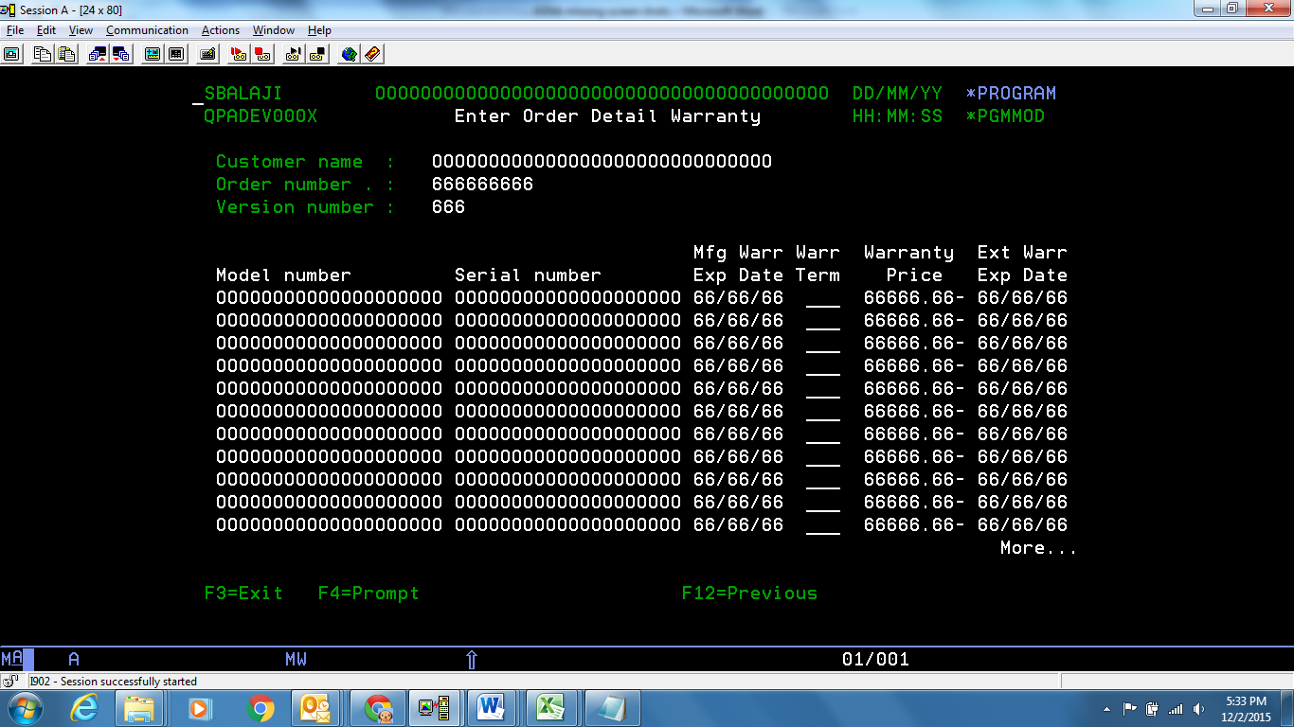

**Modernized UI:**

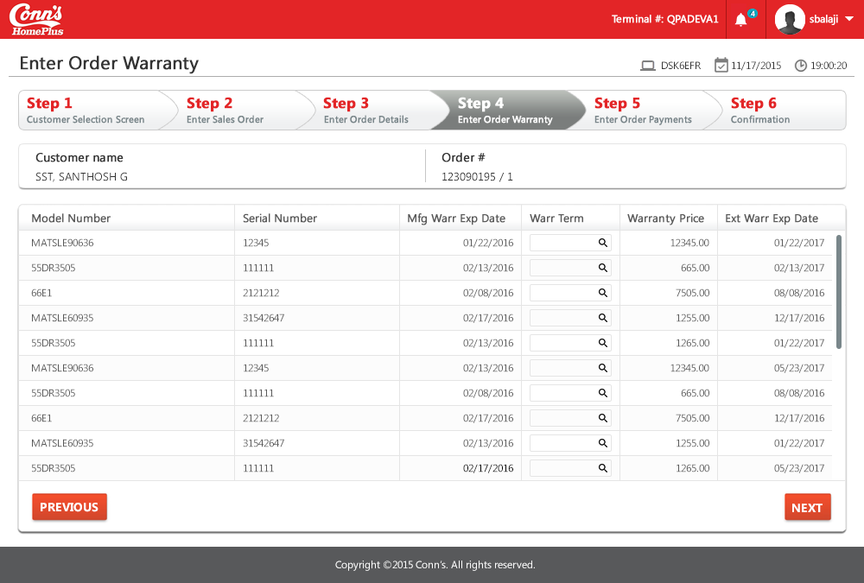

**Landing/ Entry points**

|  |  |  |  |  |
| --- | --- | --- | --- | --- |
| **Sl. No.** | **From Screen** | **Action** | **Parameters passed to this page** | **On load validations, Data Fetches** |
| 1 | Enter Order Detail - DSFMETR | Fill in the Del Sts, From Loc, Model Number, Serial Number and press “Enter” | NA | 1)DSABCPP- a. ABALTX - Customer Name 2) DSA7CPP - a.A7BANB - Order Number b. A7EXNB - ver# 3) DSA0CPP - a.A0AXTX - Model Number b. A0A8TX - Serial Number c. A0A0CD - Warrenty Term d. A0AIPR - Warrenty Pricee. Current date + 1Year = MfgWarrExp Date f. Current Date + Warrenty term in month = Ext WarrExp date. |

**Function Keys**

|  |  |  |  |  |
| --- | --- | --- | --- | --- |
| **Sl. No.** | **Function Key** | **Column name (if applicable)** | **Goes to screen ID** | **Validation before going to another screen** |
| 1 | F3=Exit | NA | Menu option | NA |
| 2 | F12= Previous | NA | Enter Order Detail - DSFMETR | NA |
| 3 | F4= Prompt | NA | Select Product Warranty - DIRLSRR | NA |

**List of Fields**

|  |  |  |  |  |
| --- | --- | --- | --- | --- |
| **Sl. No.** | **Column name** | **Tab Order** | **Validation** | **Backend Validation** |
| 1 | Warr Term | Start | Shall be empty | 1) DSA0CPP - a.A0A0CD - Warrenty Term |

# Screen ID: DIRLSRR

**Screen Name**: Select Product Warranty

**AS/400 Screen shot:**

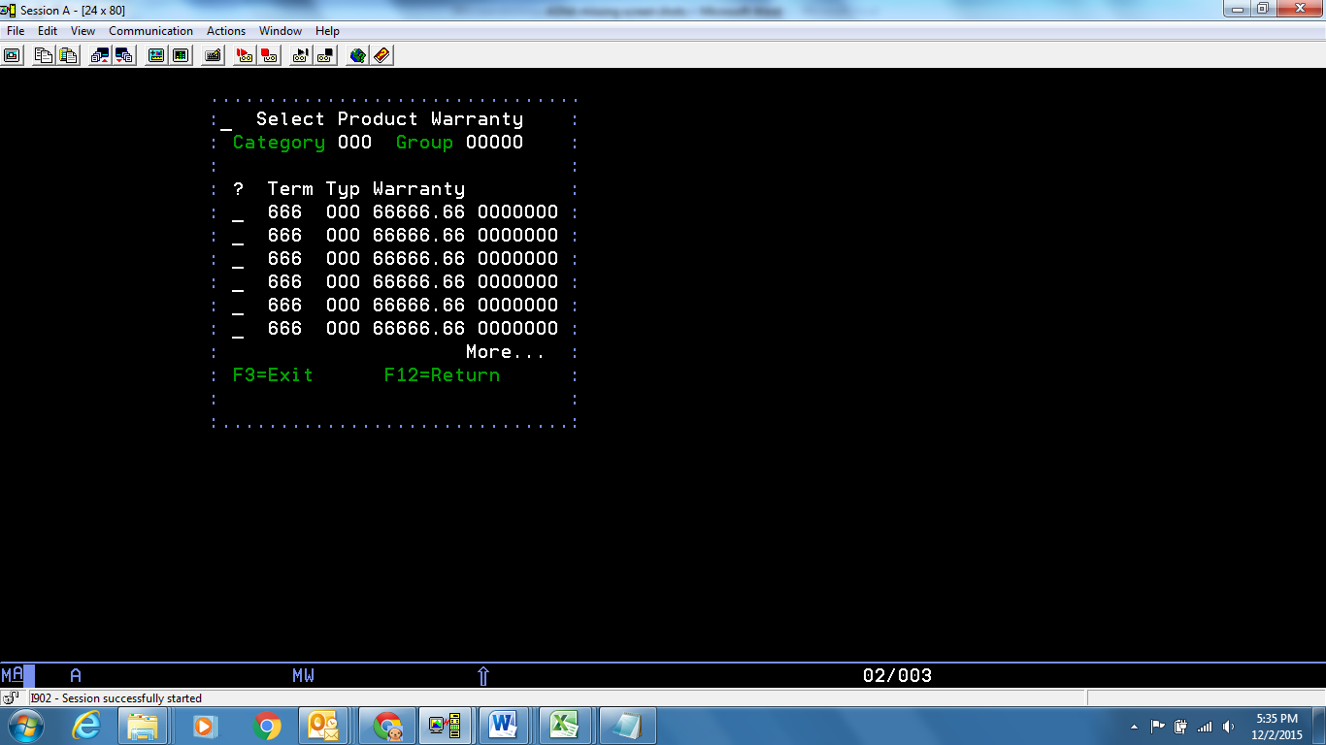

**Modernized UI:**

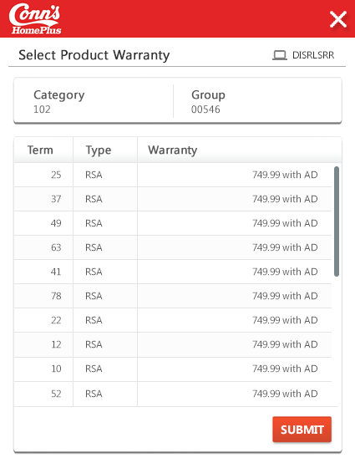

**Landing/ Entry points**

|  |  |  |  |  |
| --- | --- | --- | --- | --- |
| **Sl. No.** | **From Screen** | **Action** | **Parameters passed to this page** | **On load validations, Data Fetches** |
| 1 | Enter Order Detail Warranty - DSK6EFR | Press “F4” or press “?” and “Enter” | Model numbers of items chosen | 1) DSAXREP - a.AXAWCD -Group b.AXAXCD - Code 2)DIBFREP - a.BFAXCD - Group b.BFAWCD - Category c.BFU1CD = 'RMA' then 'RSA' d.BFFWN# - Term e.BFEMA$ - Warranty Price. |

**Function Keys**

|  |  |  |  |  |
| --- | --- | --- | --- | --- |
| **Sl. No.** | **Function Key** | **Column name (if applicable)** | **Goes to screen Id** | **Validation before going to another screen** |
| 1 | F3=Exit | NA | Enter Order Detail Warranty - DSK6EFR | NA |
| 2 | F12=Return | NA | Enter Order Detail Warranty - DSK6EFR | NA |

# Screen ID: DSEBETR

**Screen Name**: Enter Order Payments

**AS/400 Screen shot:**

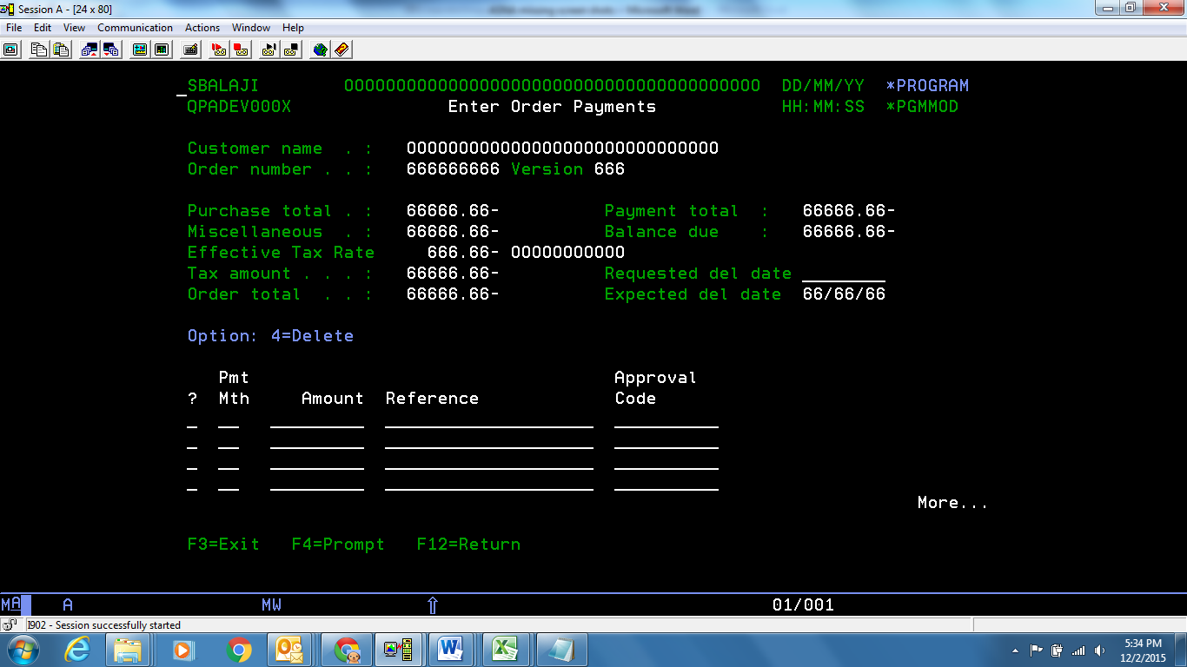

**Modernized UI:**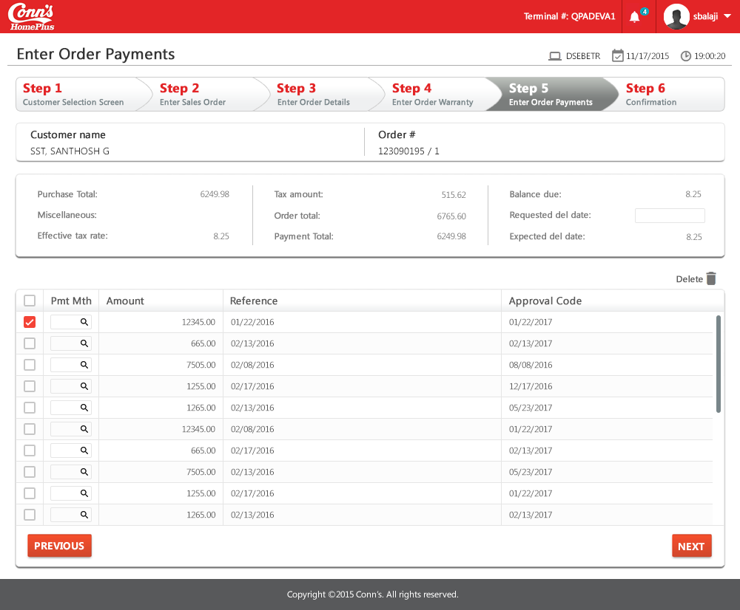

**Landing/ Entry points**

|  |  |  |  |  |
| --- | --- | --- | --- | --- |
| **Sl. No.** | **From Screen** | **Action** | **Parameters passed to this page** | **On load validations, Data Fetches** |
| 1 | Enter Order Detail Warranty - DSK6EFR | Choose warranty type if required and press “Enter” | Customer name, Order number, version number, sum of (total amount of products, warranty, installation charges, delivery charges) | Effective tax rate, tax amount  1)DSA7CPP - a.A7ALNB - Customer ID. 2)DSABCPP - a.ABALTX - Customer name. 3) DSA7CPP - a.A7BANB - Order Number b. A7EXNB - Ver# c. A7ACPC - Tax Rate. 4) DSA0CPP - a. A0AOVA - Sum of line item - Order total. 5) DSBVCPP -a.BVATVA- Payment amount. B. BVA5ST - payment Method c. BVA9TX – Reference.d. BVBATX- Approval code.  6) DSA7CPP – a. A7AXDT - Requested Delivery date. |

**Function Keys**

|  |  |  |  |  |
| --- | --- | --- | --- | --- |
| **Sl. No.** | **Function Key** | **Column name (if applicable)** | **Goes to screen ID** | **Validation before going to another screen** |
| 1 | F3=Exit | NA | Menu option | NA |
| 2 | F12=Return | NA | Enter Order Detail Warranty - DSK6EFR | NA |
| 3 | F4=Prompt | Pmt Mth | Select Payment Method - DSQJSRR |  |

**List of Fields**

|  |  |  |  |  |
| --- | --- | --- | --- | --- |
| **Sl. No.** | **Column name** | **Tab Order** | **Validation** | **Backend Validation** |
| 1 | Requested del date | Start | Not mandatory, but date should be entered in “mmddyyyy” format |  |
| 2 | ? field | 2 (moves row-wise) | Only “4” is allowed |  |
| 3 | PmtMth | 3 | Should not be blank. Only allowed methods are accepted | 1)DSBVCPP- a. BVA5ST - payment Method. |
| 4 | Amount | 4 | Should not be blank entered numeric value, with only 2 decimal places | 1)DSBVCPP – a.BVATVA- Payment amount. |
| 5 | Reference | 5 | Shall be blank (depends on type of payment method) | 1)DSBVCPP – a. BVA9TX – Reference |
| 6 | Approval Code | 6 | Shall be blank (depends on type of payment method) | 1)DSBVCPP- a. BVBATX- Approval code. |

# Screen ID: DSQJSRR

**Screen Name**: Select Payment Method

**AS/400 Screen shot:**

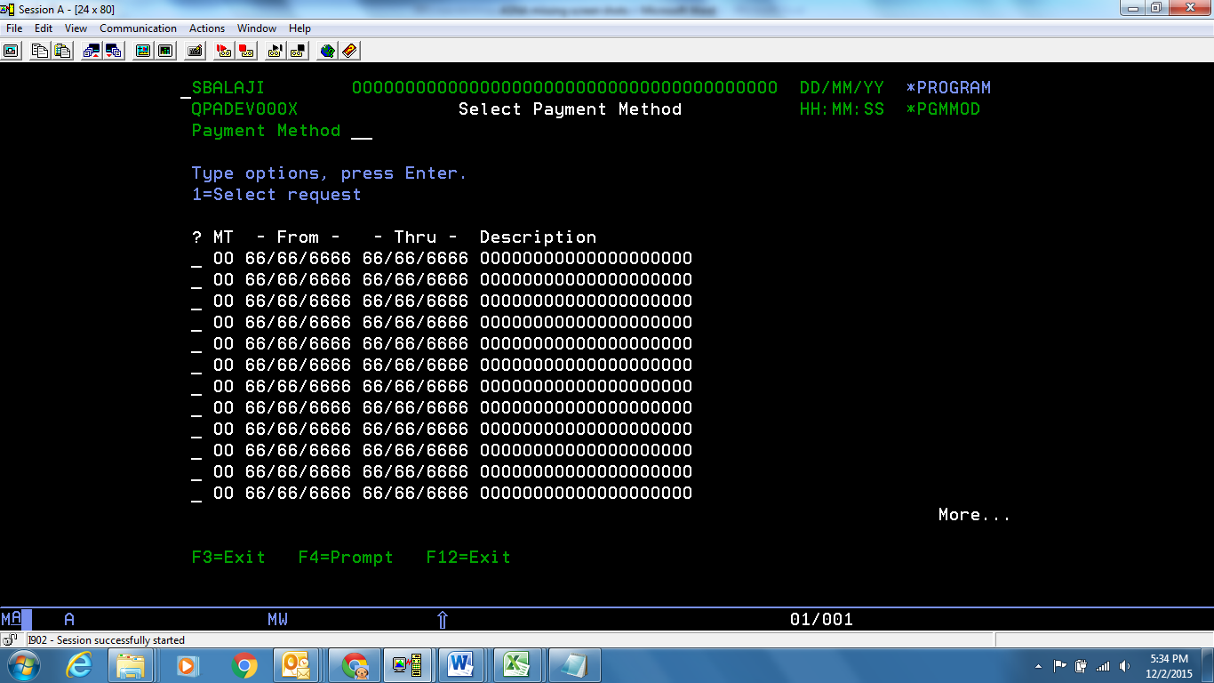

**Modernized UI:**

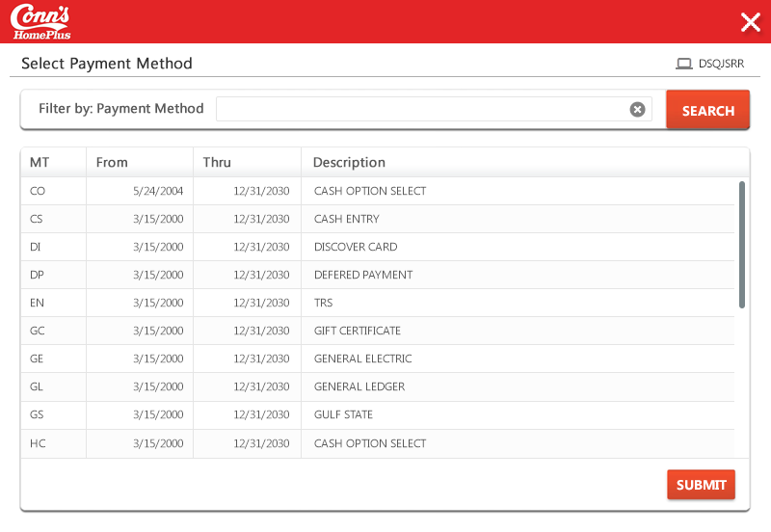

**Landing/ Entry points**

|  |  |  |  |  |
| --- | --- | --- | --- | --- |
| **Sl. No.** | **From Screen** | **Action** | **Parameters passed to this page** | **On load validations, Data Fetches** |
| 1 | Enter Order Payments - DSEBETR | Press “F4” by placing the pointer in “Pmt mth” field | NA | NA  1) DSH2REP - a.H2MHCD - Payment Method b.H2D1DT - Date From c.H2D2DT - Date thro d.H2P9TX – Description |

**Function Keys**

|  |  |  |  |  |
| --- | --- | --- | --- | --- |
| **Sl. No.** | **Function Key** | **Column name (if applicable)** | **Goes to screen ID** | **Validation before going to another screen** |
| 1 | F3=Exit | NA | Enter Order Payments - DSEBETR | NA |
| 2 | F12=Exit | NA | Enter Order Payments - DSEBETR | NA |
| 3 | F4=Prompt | Payment Method | Error - Prompt not valid for this field | NA |
| 4 | 1=Select Request | ? fields | Enter Order Payments - DSEBETR | NA |

# Screen ID: DIQXDFR

**Screen Name**: IN: SKU Bar Code X- ref

**AS/400 Screen shot:**

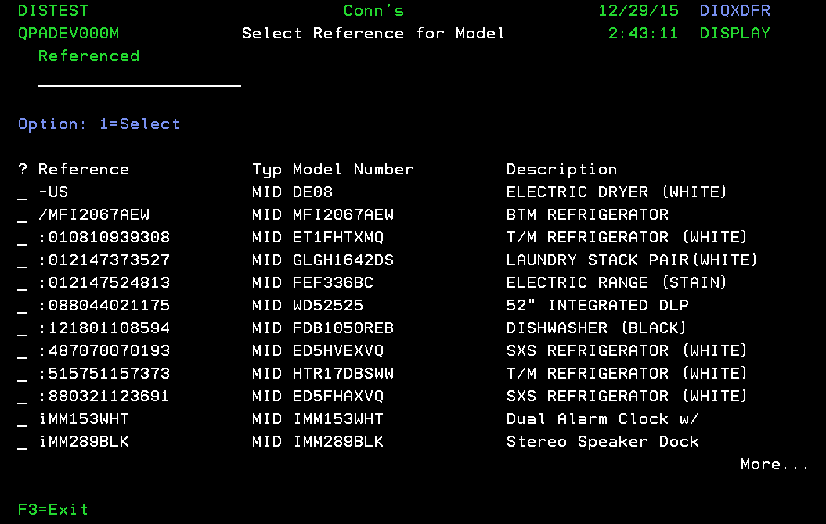

**Modernized UI:**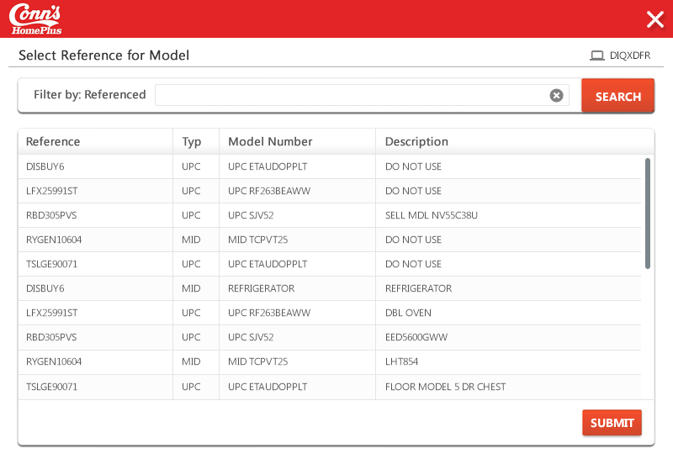

**Landing/ Entry points**

|  |  |  |  |  |
| --- | --- | --- | --- | --- |
| Sl. No. | From Screen | Action | Parameters passed to this page | On load validations, Data Fetches |
|  | DSWXDFR - Model Inquiry | Hit F6=X-Ref | N.A | 1) DSHNCPP – a. HNAXTX – Model number b. HNQ1TX – Type c. HNOICD – Reference. 2) DSAXREP – a. AXAXTX – Model number b. AXA2TX – Model description. |

**Function Keys**

|  |  |  |  |  |
| --- | --- | --- | --- | --- |
| Sl. No. | Function Key | Column name (if applicable) | Goes to screen Id | Validation before going to another screen |
|  | F3=Exit | NA | DSWXDFR - Model Inquiry | NA |
|  | F12=Previous | N.A | DSWXDFR - Model Inquiry |  |
|  | 1=Select | ? | DSWXDFR - Model Inquiry |  |

**List of Fields**

|  |  |  |  |  |
| --- | --- | --- | --- | --- |
| **Sl. No.** | **Column name** | **Tab Order** | **Validation** | **Backend Validation** |
| 1 | Referenced | Start | Can be any character. |  |
| 2 | ? field | 2 (moves row-wise) | Only “1”=Select is allowed |  |

# Screen ID: DSM7DFR

**Screen Name**: CO: Location Display Inventory for reserve model

**AS/400 Screen shot:**

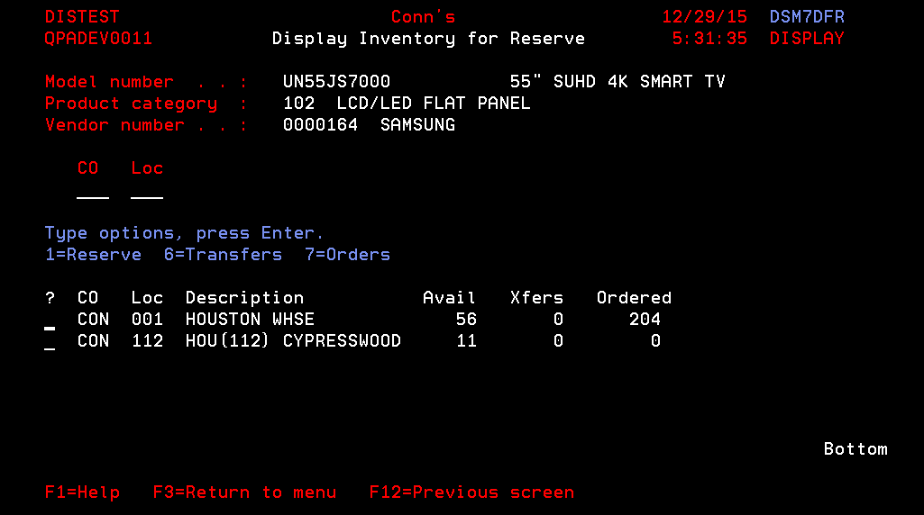

**Modernized UI:**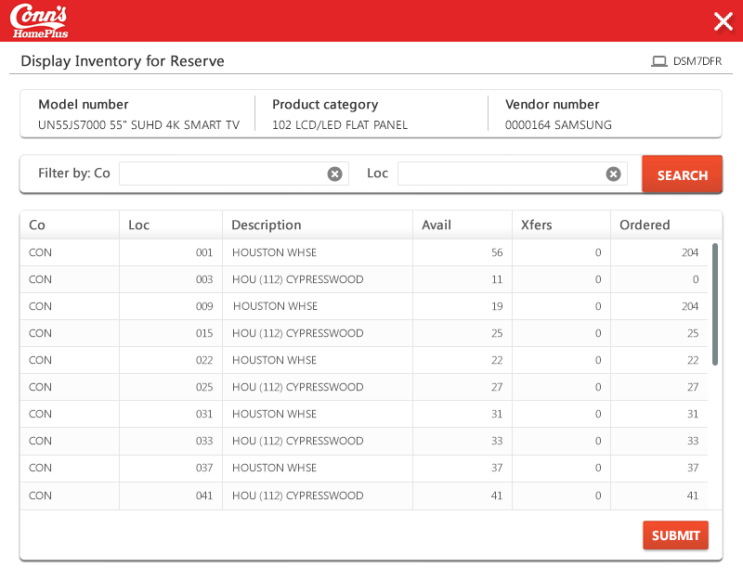

**Landing/ Entry points**

|  |  |  |  |  |
| --- | --- | --- | --- | --- |
| Sl. No. | From Screen | Action | Parameters passed to this page | On load validations, Data Fetches |
|  | DSWXDFR - Model Inquiry | Take 5=Display inventory select against a Model and Hit Enter. | N.A | 1)DSAXREP – a. AXAXTX – Model Number b. AXA2TX – Model Description c. AXBLNB – Vendor number d. AXAXCD – Product Code Category. 2) DSBKREP – a. BKA6TX – Product category description 3) DSBAR  DSC4PVR  EP – a. BABBTX – vendor Name. 4) DSADREP – A. ADABCD – Company code b. ADAACD – Location code and query it and get the value of ADAFCD – Primary Warehouse 5) DSA3CPP – A. A3ABCD – Company b. A3AACD – Location(Use the Primary warehouse and Current location name) c. A3AXTX – Model number D. A3APST = ‘ORD’ - A3A6NB – Ordered, A3APST = (ONH – RSV) = Avail Balance. |

**Function Keys**

|  |  |  |  |  |
| --- | --- | --- | --- | --- |
| Sl. No. | Function Key | Column name (if applicable) | Goes to screen Id | Validation before going to another screen |
|  | F3=Return to menu | NA | DSWXDFR - Model Inquiry | NA |
|  | F12=Previous screen |  | DSWXDFR - Model Inquiry |  |
|  | 1=Reserve | ? | DSFMETR - Enter Order Detail |  |
|  | 6=Transfer | ? | DSM0DFR - Display Incoming Transfer |  |
|  | 7=Order | ? | DSM1DFR - Display Incoming PO's |  |
|  | Enter key | N.A | Remians in same page. |  |

**List of Fields**

|  |  |  |  |  |
| --- | --- | --- | --- | --- |
| **Sl. No.** | **Column name** | **Tab Order** | **Validation** | **Backend Validation** |
| 1 | Company | Start | Can be any character. |  |
|  | Location | 2 | Can be any character. |  |
| 2 | ? field | 3 (moves row-wise) | Only “1”=Reserve “6”=Transfers “7”=Ordersis allowed |  |

# Screen ID: DSM0DFR

**Screen Name:** IN: Transpo Detail

**AS/400 Screen shot:**

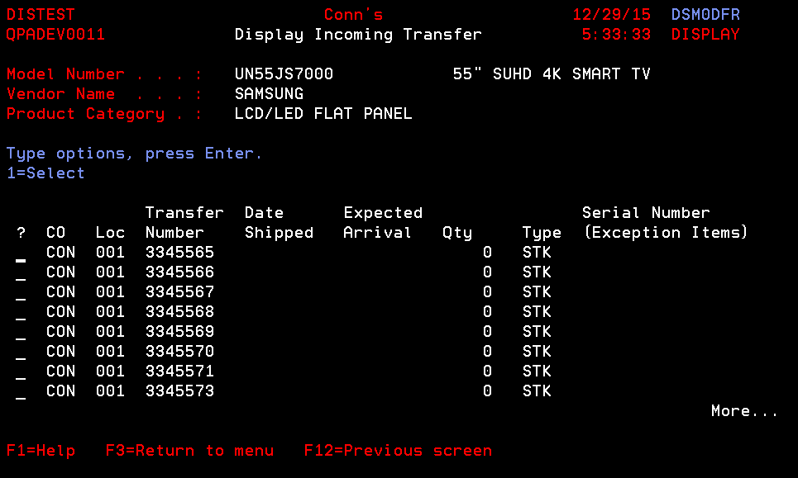

**Modernized UI:**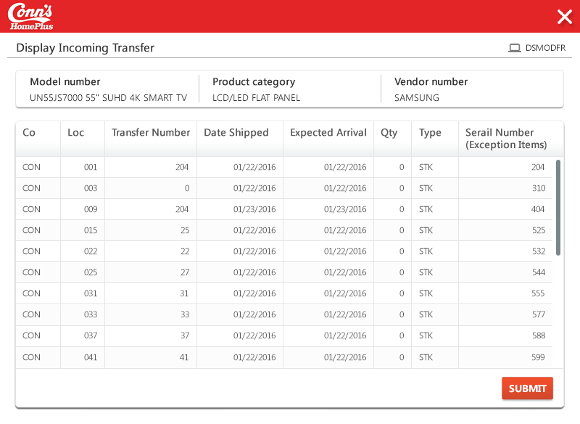

**Landing/ Entry points**

|  |  |  |  |  |
| --- | --- | --- | --- | --- |
| Sl. No. | From Screen | Action | Parameters passed to this page | On load validations, Data Fetches |
|  | DSM7DFR - Display Inventory for Reserve | Take 6=Transfers against a Line. |  |  |

**Function Keys**

|  |  |  |  |  |
| --- | --- | --- | --- | --- |
| Sl. No. | Function Key | Column name (if applicable) | Goes to screen Id | Validation before going to another screen |
|  | F3=Return to menu | NA | DSFMETR - Enter Order Detail | NA |
|  | F12=Previous screen |  | DSM7DFR - Display Inventory for Reserve |  |
|  | 1=Select |  | DSFMETR - Enter Order Detail |  |
|  | Enter key |  | Remains in the same screen. |  |

# Screen ID: CCKFPVR

**Screen Name:** Prompt for Credit Application Entry

**AS/400 Screen shot:**

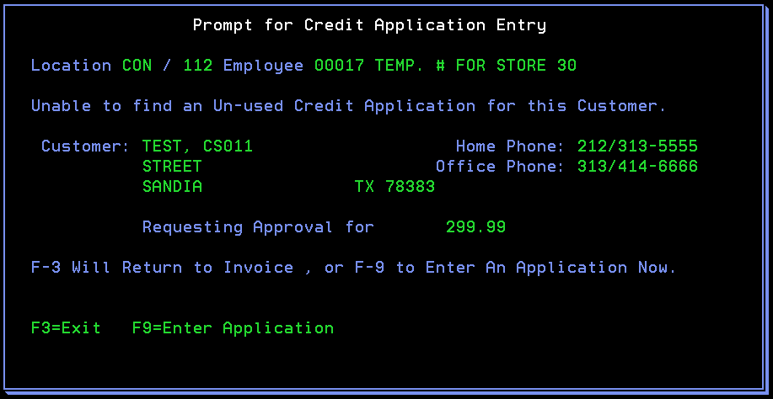

**Modernized UI:**

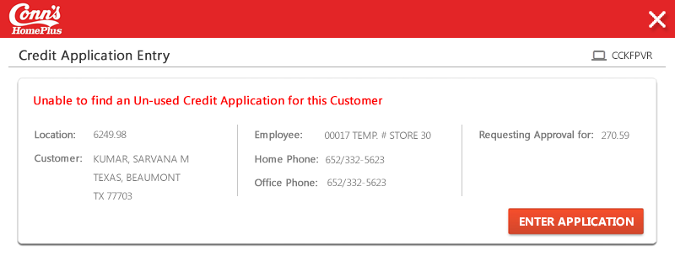

**Landing/ Entry points**

|  |  |  |  |  |
| --- | --- | --- | --- | --- |
| Sl. No. | From Screen | Action | Parameters passed to this page | On load validations, Data Fetches |
|  | DSEBETR - Enter Order Payments | Hit Enter after specifying Payment method and Amount. | N.A |  |

**Function Keys**

|  |  |  |  |  |
| --- | --- | --- | --- | --- |
| Sl. No. | Function Key | Column name (if applicable) | Goes to screen Id | Validation before going to another screen |
|  | F3=Exit | NA | DSEBETR - Enter Order Payments | NA |
|  | F9=Enter Application | N.A | CCHXE1R - Edit Personal Details |  |
|  | F12=Previous | NA | DSEBETR - Enter Order Payments |  |
|  | Enter key | NA | DSEBETR - Enter Order Payments |  |

# Screen ID: CCLVD1R

**Screen Name:** Display Application Status - OE: DSW Appl Status KEY SCREEN Display Application Status

**AS/400 Screen shot:**

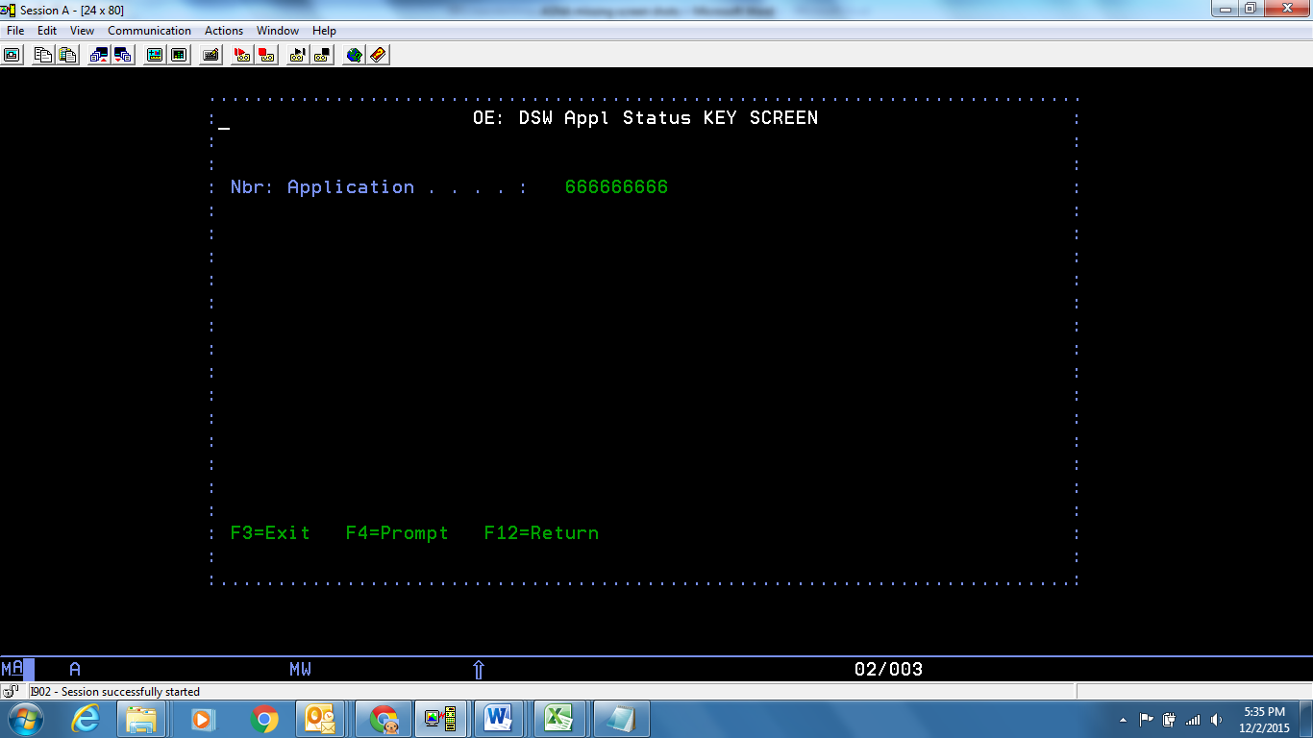

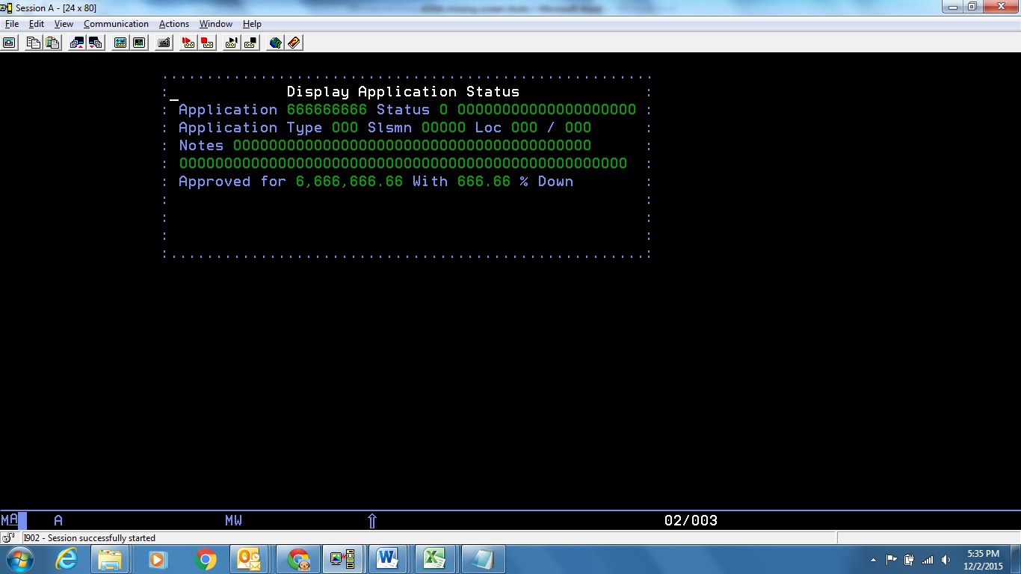

**Modernized UI:**

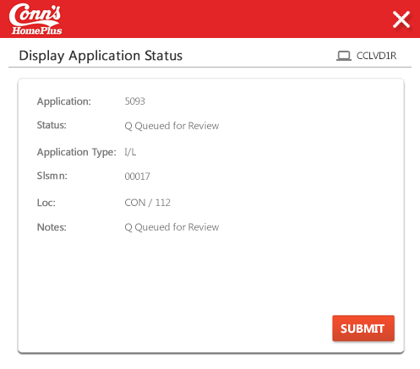

**Landing/ Entry points**

|  |  |  |  |  |
| --- | --- | --- | --- | --- |
| Sl. No. | From Screen | Action | Parameters passed to this page | On load validations, Data Fetches |
|  | DSEBETR - Enter Order Payments |  |  |  |
|  |  |  |  |  |

**Function Keys**

|  |  |  |  |  |
| --- | --- | --- | --- | --- |
| Sl. No. | Function Key | Column name (if applicable) | Goes to screen Id | Validation before going to another screen |
|  | F3=Exit | NA | DSEBETR - Enter Order Payments | NA |
|  | F4=Prompt | N.A | N.A |  |
|  | F12=Return |  | DSEBETR - Enter Order Payments |  |
|  | Enter key | N.A | DSEBETR - Enter Order Payments |  |

# Screen ID: DIJ5DFR

**Screen Name:** DSP Number No Maint Display File

**AS/400 Screen shot:**

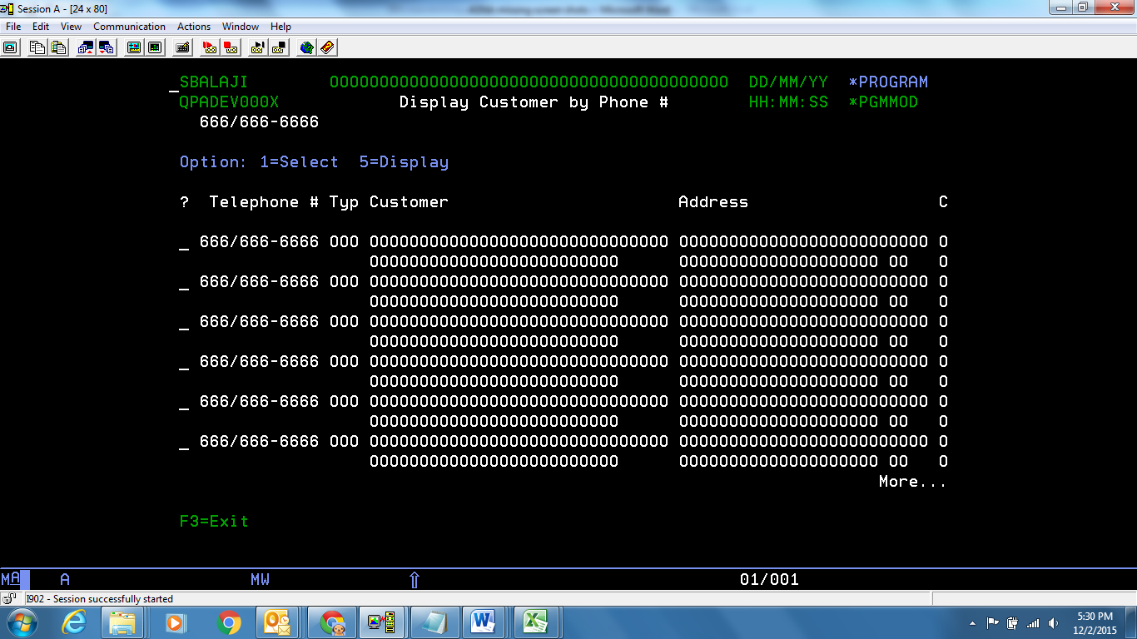

**Modernized UI:**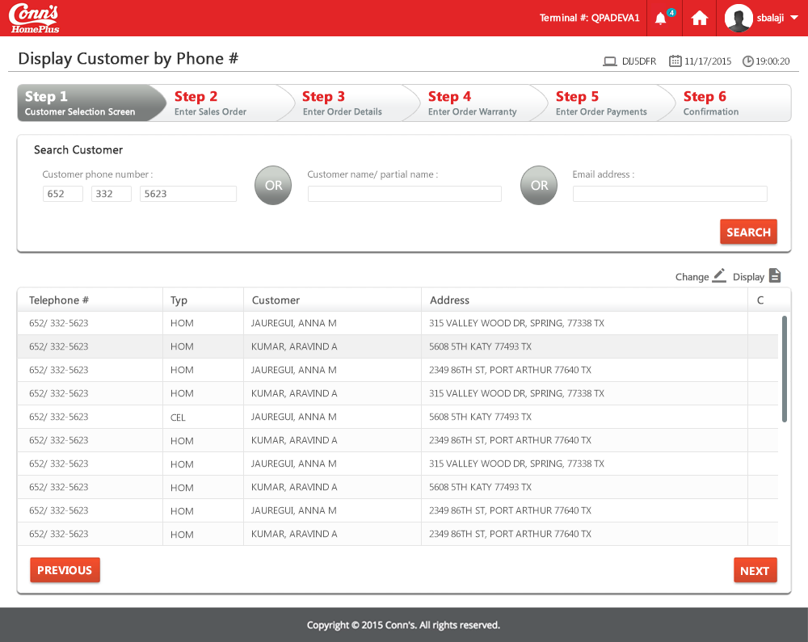

**Landing/ Entry points**

|  |  |  |  |  |
| --- | --- | --- | --- | --- |
| **Sr. No.** | **From Screen** | **Action** | **Parameters passed to this page** | **On load validations, Data Fetches** |
| 1 | Select TRS Ship-to Customer – DSGQPVI | Enter a customer’s phone number and press “Enter” | Search string entered |  |

**Function Keys**

| **Sr. No.** | **Function Key** | **Column name (if applicable)** | **Goes to screen ID** | **Validation before going to another screen** |
| --- | --- | --- | --- | --- |
| 1 | F3=Exit | NA | Select TRS Ship-to Customer – DSGQPVI | NA |
| 2 | 1=Select | NA | Enter Sales Order Header – DSDZETR | NA |
| 3 | 5=Display | NA | Display Customer Details - DSC7D1R |  |
| 4 | F12 | NA | Select TRS Ship-to Customer – DSGQPVI |  |
| 5 | 2=Change | NA | NA |  |

# Screen ID: DSC7D1R

**Screen Name**: Display Customer details (for selected row)

**AS/400 Screen shot:**

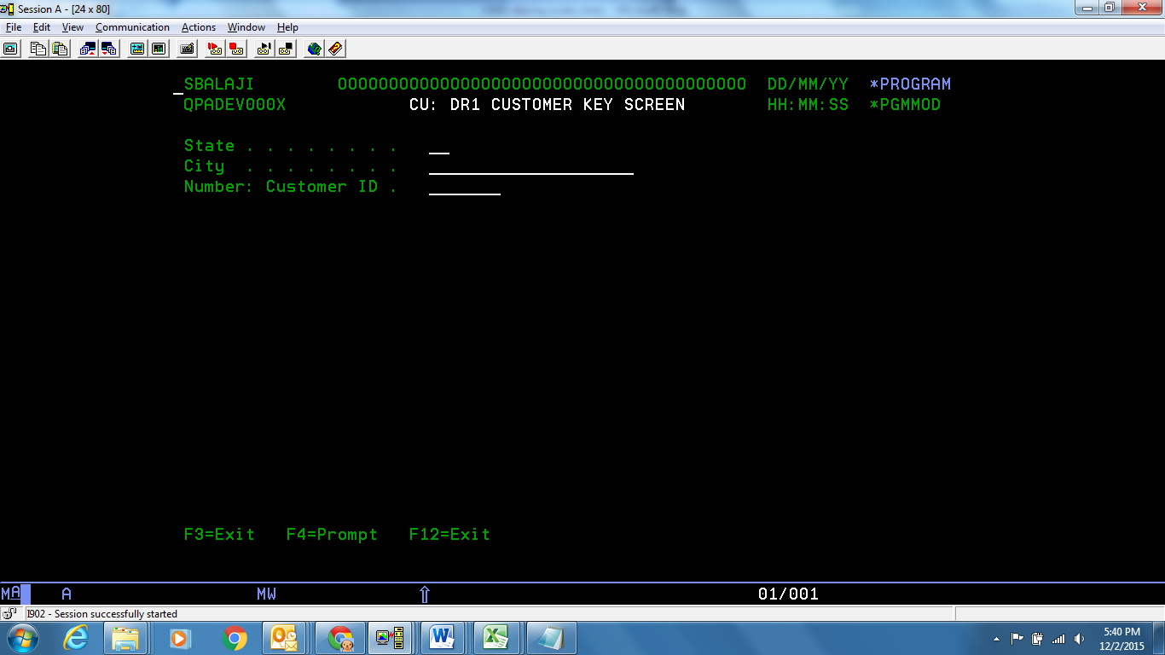

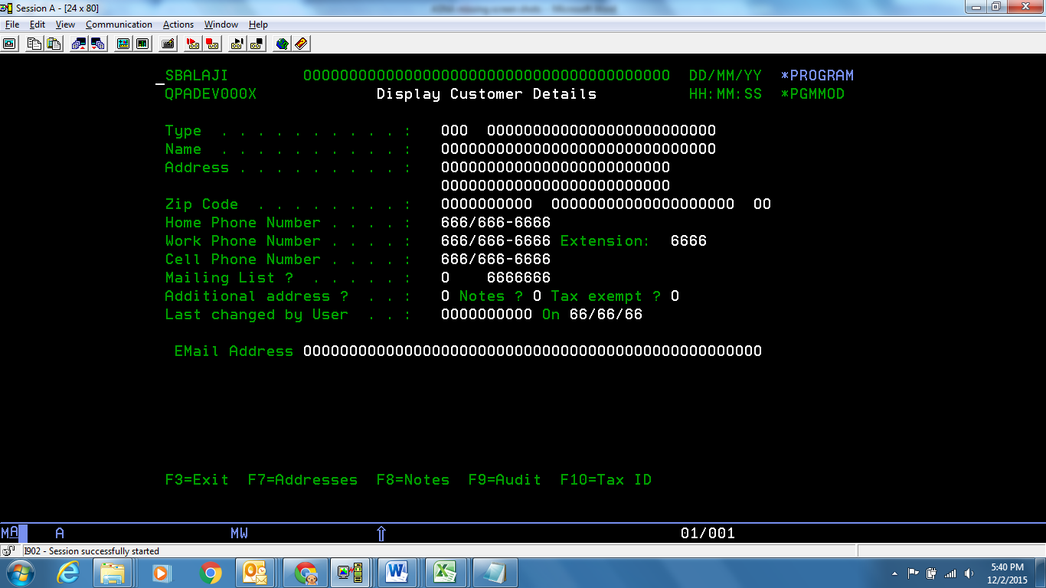

**Modernized UI:**

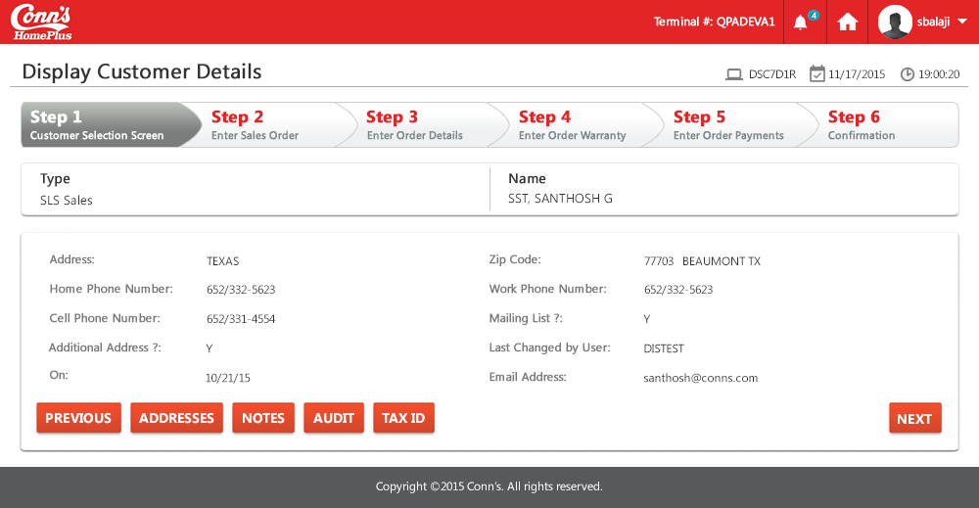

**Landing/ Entry points**

|  |  |  |  |  |
| --- | --- | --- | --- | --- |
| **Sr. No.** | **From Screen** | **Action** | **Parameters passed to this page** | **On load validations, Data Fetches** |
| 1 | Display Customer by Phone # - DIBHDFR | Press “5” across the customer whose details are to be viewed | Search string entered in previous screen |  |
| 2 | Display Customer – DSBPDFR | Press “5” across the customer whose details are to be viewed | Search string entered in previous screen |  |
| 3 | Select Email for Customer – DSHRSRI | Press “5” across the customer whose details are to be viewed | Search string entered in previous screen |  |

**Function Keys**

|  |  |  |  |  |
| --- | --- | --- | --- | --- |
| **Sr. No.** | **Function Key** | **Column name (if applicable)** | **Goes to screen Id** | **Validation before going to another screen** |
| 1 | F4=Prompt | NA | NA | NA |
| 2 | F3=Exit | NA | Menu Options or DIBHDFR or DIMPDFR | NA |
| 3 | F12=Exit | NA | DIBHDFR (or) DSBPDFR (or) DSHRSRI | NA |
| 4 | F7=Address | NA | Customer Addresses - DIMLDFR |  |
| 5 | F8=Note | NA | Edit Customer Notes - DSHFETR |  |
| 6 | F9=Audit | NA | Display Customer Changes - DSP4DFR |  |
| 7 | F10=Tax ID | NA | Edit Tax Exempt ID - DSCZE1R |  |

**List of Fields**

| **Sr. No.** | **Column name** | **Tab Order** | **Validation** | **Backend Validation** |
| --- | --- | --- | --- | --- |
| 1 | All fields | NA | Would be automatically filled on loading |  |

# Screen ID: DSCADFR

**Screen Name**: Display Customer Comments

**AS/400 Screen shot:**

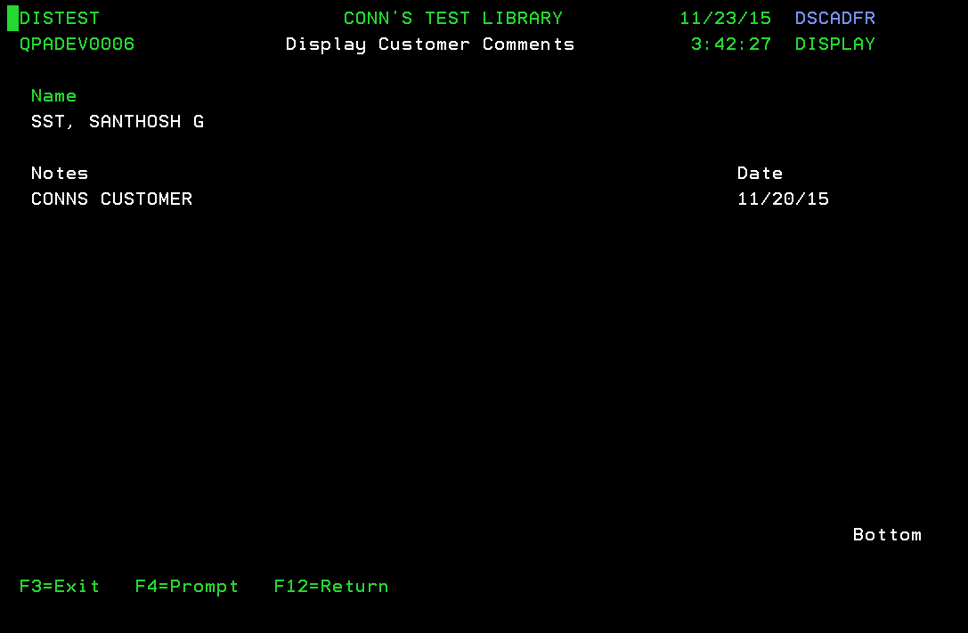

**Modernized UI:**

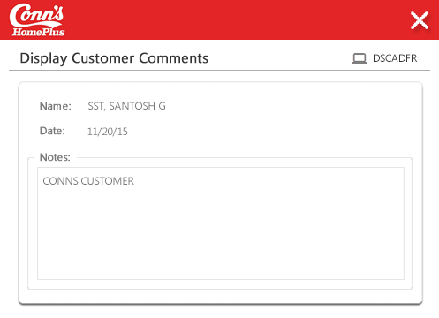

**Landing/ Entry points**

|  |  |  |  |  |
| --- | --- | --- | --- | --- |
| **Sr. No.** | **From Screen** | **Action** | **Parameters passed to this page** | **On load validations, Data Fetches** |
| 1 | Display Customer Details - DSC7D1R | Press “F8” |  |  |

**Function Keys**

| **Sr. No.** | **Function Key** | **Column name (if applicable)** | **Goes to screen ID** | **Validation before going to another screen** |
| --- | --- | --- | --- | --- |
| 1 | F4=Prompt | NA | NA | NA |
| 2 | F3=Exit | NA | Menu Option | NA |
| 3 | F12=Return | NA | Display Customer Details - DSC7D1R | NA |

**List of Fields:**

* Display output fields , it will populate the customer comments associated with the customer details.

# Screen ID: DSIME1R

**Screen Name**: Edit Customer Details- CU: ER1 Customer Maint Edit record(1 screen) - Edit Customer Details

**AS/400 Screen shot:**

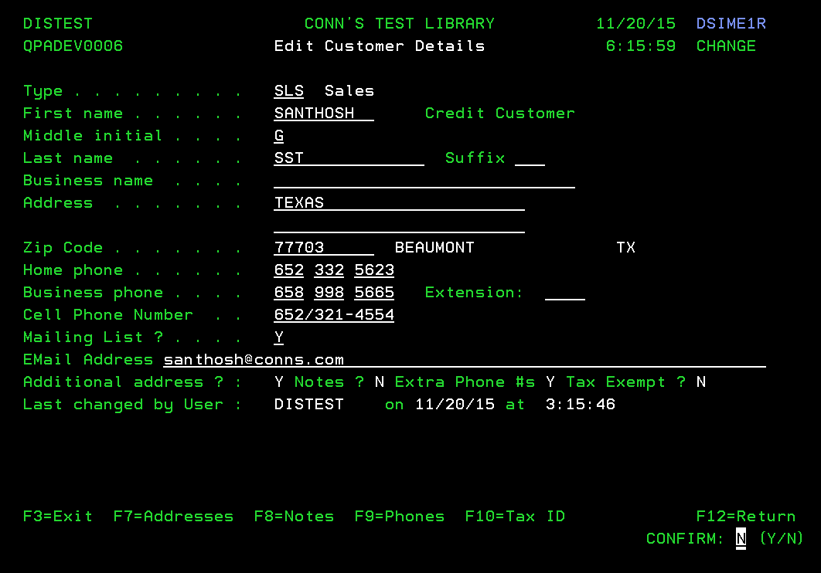

**Modernized UI:**

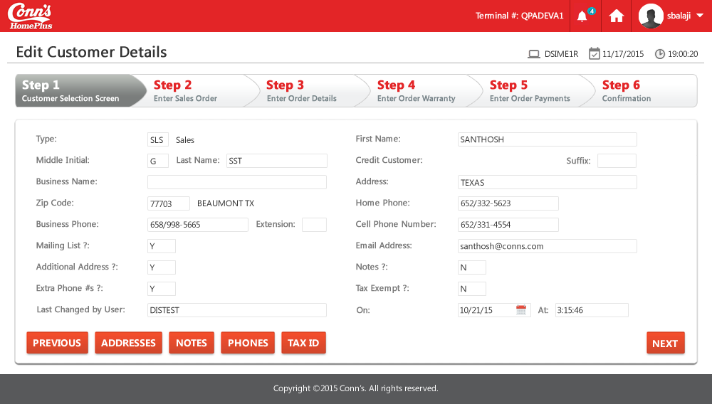

**Landing/ Entry points**

|  |  |  |  |  |
| --- | --- | --- | --- | --- |
| **Sr. No.** | **From Screen** | **Action** | **Parameters passed to this page** | **On load validations, Data Fetches** |
| 1 | Display Customer by Phone # - DIBHDFR | Press “2” across the customer whose details are to be viewed | Search string entered in previous screen |  |
| 2 | Display Customer - DSBPDFR | Press “2” across the customer whose details are to be viewed | Search string entered in previous screen |  |

**Function Keys**

| **Sr. No.** | **Function Key** | **Column name (if applicable)** | **Goes to screen ID** | **Validation before going to another screen** |
| --- | --- | --- | --- | --- |
| 1 | F7=Address | NA | Customer Addresses – DIMLDFR | NA |
| 2 | F3=Exit | NA | Menu Options | NA |
| 3 | F12=Return | NA | Display Customer – DSBPDFR | NA |
| 4 | F9=Phones | NA | Display Phone Numbers – DSRBDFR |  |
| 5 | F8=Notes | NA | Edit Customer Notes – DSHFETR |  |
| 6 | F10=Tax ID | NA | Edit Tax Exempt ID - DSCZE1R |  |

**List of Fields**

|  |  |  |  |  |
| --- | --- | --- | --- | --- |
| **Sr. No.** | **Column name** | **Tab Order** | **Validation** | **Backend Validation** |
| 1 | Type | Start | Only allowed values can be used. Mandatory field |  |
| 2 | First name | 2 | Allows both numbers and alphabets |  |
| 3 | Last Name | 4 | Allows both numbers and alphabets |  |
| 4 | Middle Initial | 3 | Allows both numbers and alphabets |  |
| 5 | Suffix | 5 | Allows both numbers and alphabets |  |
| 6 | Business Name | 6 | Allows both numbers and alphabets |  |
| 7 | Address | 7, 8 (2nd line) | Allows both numbers ,alphabets and Special Characters. |  |
| 8 | Zip Code | 9 | Allows only 5 digits. Logically should not allow characters. But allowed here |  |
| 9 | Home Phone | 10, 11, 12 | Split into 3 section in format (xxx-xxx-xxxx). Should be able to enter only numbers |  |
| 10 | Business Phone | 13, 14, 15 | Split into 3 section in format (xxx-xxx-xxxx). Should be able to enter only numbers |  |
| 11 | Cell Phone Number | 17 | Should be able to enter only numbers |  |
| 12 | Extension | 16 | Should be able to enter only numbers |  |
| 13 | Mailing List | 18 | Only allowed values shall be entered (Y, 0, 1, 2, 3, 4, 5) |  |
| 14 | Email Address | 19 | Should be in abc@example.com format |  |
| 15 | Additional Address, Notes, Extra Phone #s, Tax Exempt | NA | Will be populated automatically |  |
| 16 | Last Changed by User, on, at | NA | Will be populated automatically |  |

# Screen ID: DIMLDFR

**Screen Name**: Customer Addresses– CU: DSP Cust Addresses Display file - Customer Addresses

**AS/400 Screen shot:**

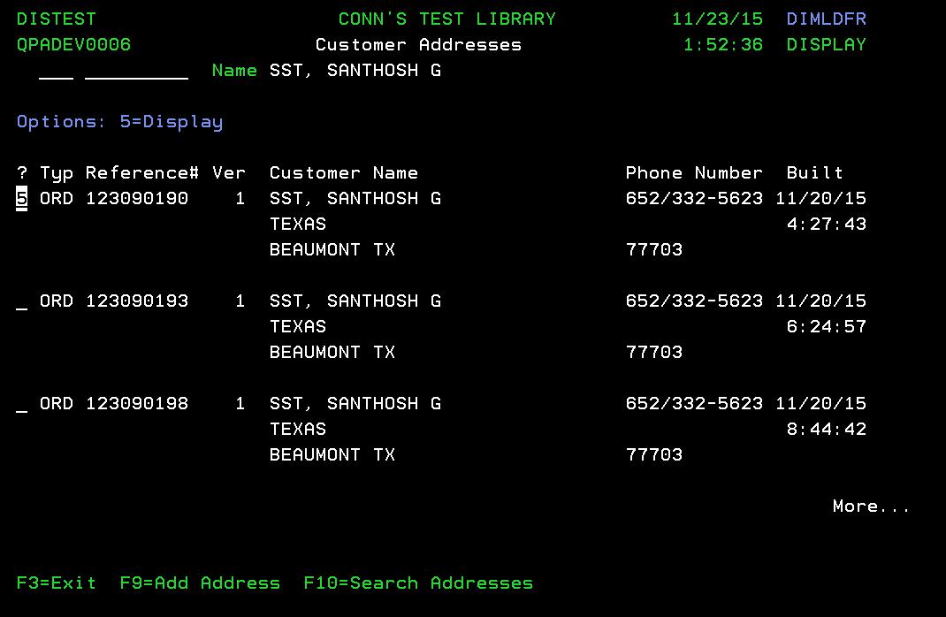

**Modernized UI:**

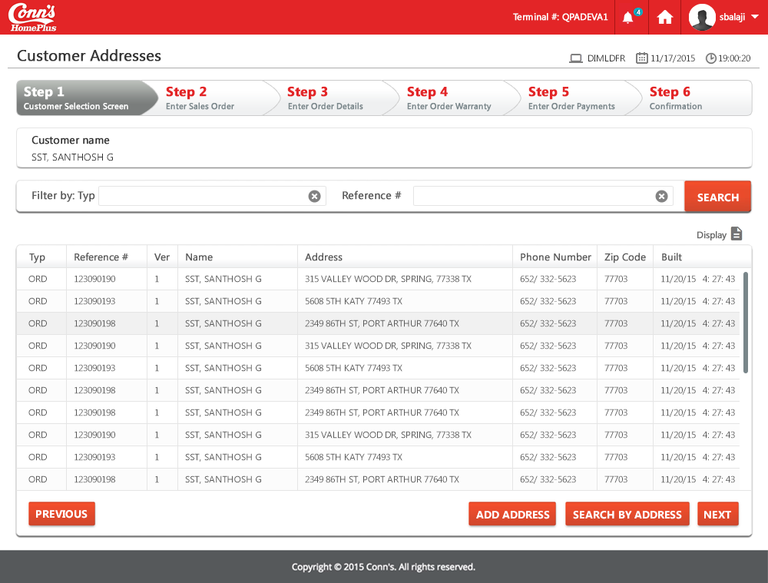

**Landing/ Entry points**

|  |  |  |  |  |
| --- | --- | --- | --- | --- |
| **Sr. No.** | **From Screen** | **Action** | **Parameters passed to this page** | **On load validations, Data Fetches** |
| 1 | Display Customer Details - DSC7D1R | Press “F7” | Customer Name, phone numbers |  |
| 2 | Edit Customer Details - DSIME1R | Press “F7” | Customer Name, phone numbers |  |
|  |  |  |  |  |

**Function Keys**

| **Sr. No.** | **Function Key** | **Column name (if applicable)** | **Goes to screen ID** | **Validation before going to another screen** |
| --- | --- | --- | --- | --- |
| 1 | F3=Exit | NA | Menu Option | NA |
| 2 | F9=Add Address | NA |  |  |
| 3 | F10=Search Address | NA | Display Addresses for Customers - DIQADFR |  |
| 4 | 5=Display |  | Display Completed Order Header - DSU5DTR |  |

**List of Fields**

|  |  |  |  |  |
| --- | --- | --- | --- | --- |
| **Sr. No.** | **Column name** | **Tab Order** | **Validation** | **Backend Validation** |
| 1 | Type filter | Start | Just like a filter (optional) |  |
| 2 | Reference # filter | 2 | Just like a filter (optional) |  |
| 3 | ? | 3 | Only “5” can be entered |  |
| 4 | Typ | NA | Will be filled automatically with the type of address |  |
| 5 | Reference # | NA | Will be filled automatically |  |
| 6 | Ver | NA | Will be filled automatically |  |
| 7 | Customer Name | NA | Will be filled automatically, with address |  |
| 8 | Phone Number | NA | Will be filled automatically |  |
| 9 | Built | NA | Will be filled automatically |  |

# Screen ID: DIOQD1I

**Screen Name**: Customer Address Key Screen – CU: DS1 Customer Address Display record(1 screen) - CU: DS1 Customer Address KEY SCREEN

**AS/400 Screen shot:**

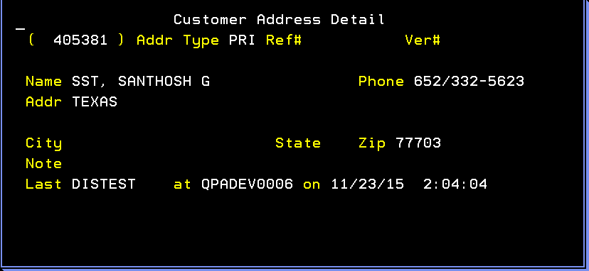

**Modernized UI:**

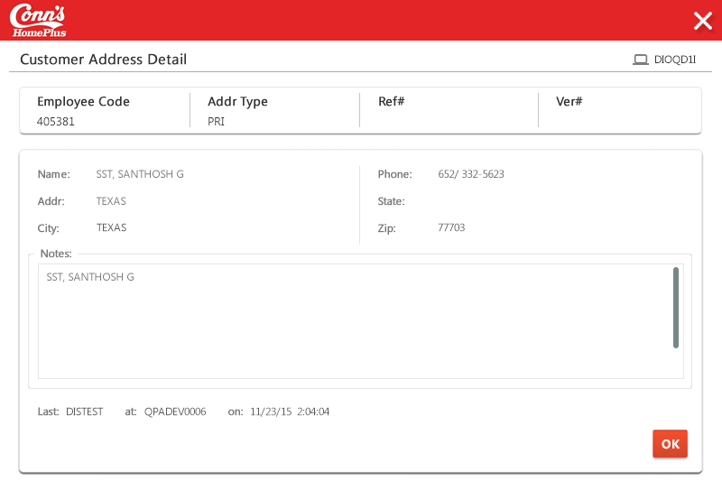

**Landing/ Entry points**

|  |  |  |  |  |
| --- | --- | --- | --- | --- |
| Sr. No. | From Screen | Action | Parameters passed to this page | On load validations, Data Fetches |
|  | DIMLDFR - Customer  Addresses | When Typ – PRI on DIMLDFR - Customer  Addresses | N.A. |  |

**Function Keys**

-- None --

**List of Fields**

It is a display output field, which will display the customer address details.

# Screen ID: DSNJDTR

**Screen Name**: Display Order Header Data - OE: DTR DspOrdHdr Display transactions - Display Order Header Data

**AS/400 Screen shot:**

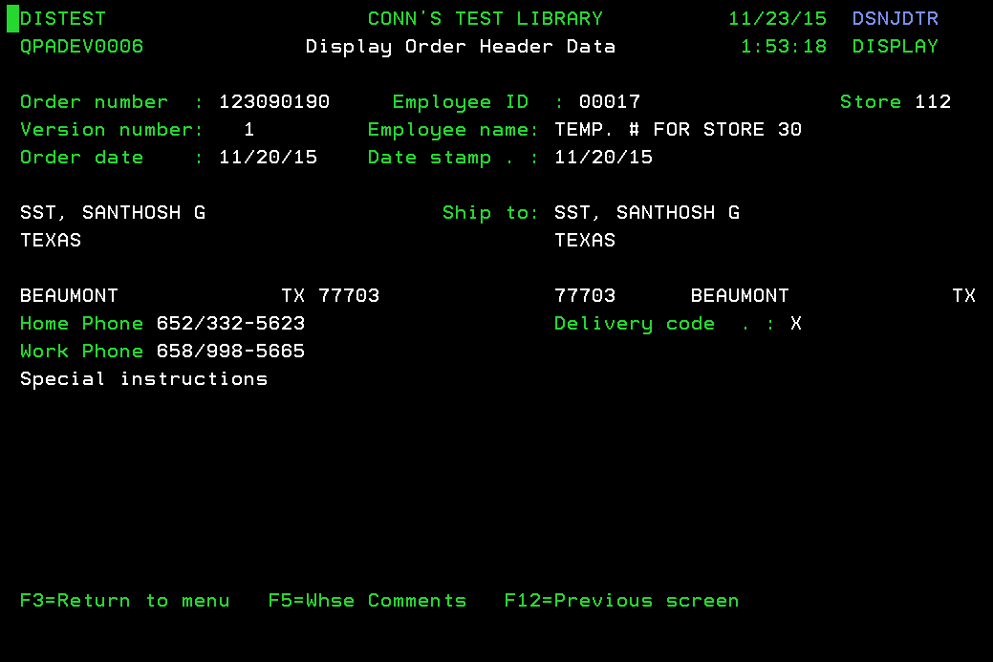

**Modernized UI:**

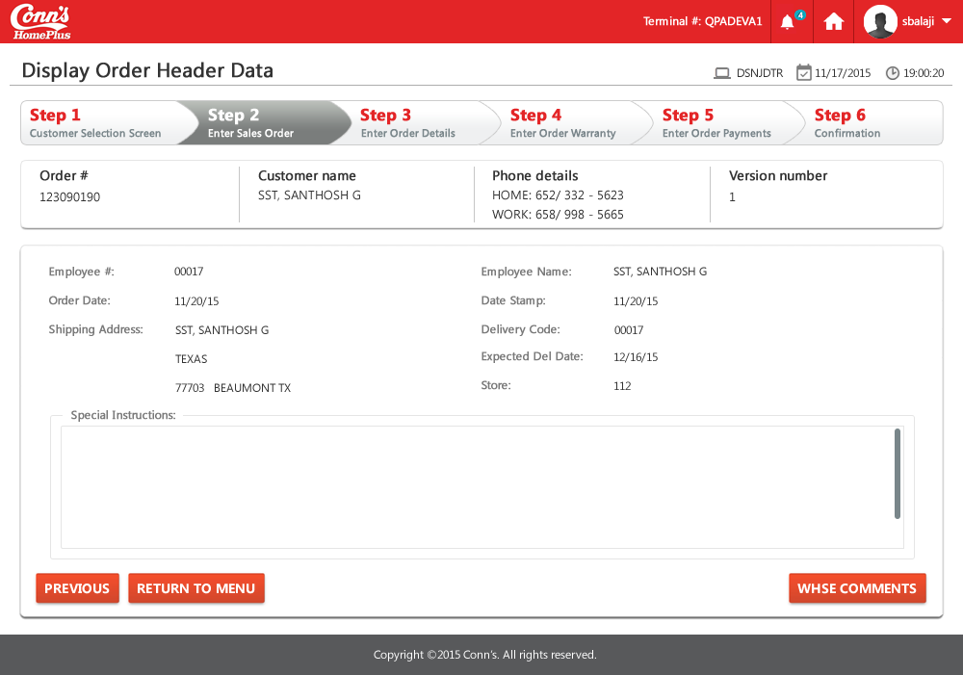

**Landing/ Entry points**

|  |  |  |  |  |
| --- | --- | --- | --- | --- |
| **Sr. No.** | **From Screen** | **Action** | **Parameters passed to this page** | **On load validations, Data Fetches** |
| 1 | Select Customer Orders - DSHQDFR | Enter “5” in the “?” column for which the details are to be displayed,  When the typ – ORD or SHP. | Order Number |  |

**Function Keys**

|  |  |  |  |  |
| --- | --- | --- | --- | --- |
| **Sr. No.** | **Function Key** | **Column name (if applicable)** | **Goes to screen ID** | **Validation before going to another screen** |
| 1 | F3=Return to menu | NA | Customer Addresses - DIMLDFR | NA |
| 2 | F12=Previous Screen | NA | Customer Addresses - DIMLDFR | NA |
| 3 | F5=Whse Comments | NA | Display Whse Comments - DST1DFR | NA |

# Screen ID: DIQADFR

**Screen Name**: Display Addresses for Customer f9 - CU: DSP Addresses 4 Cust Display file - Display Addresses for Customers

**AS/400 Screen shot:**

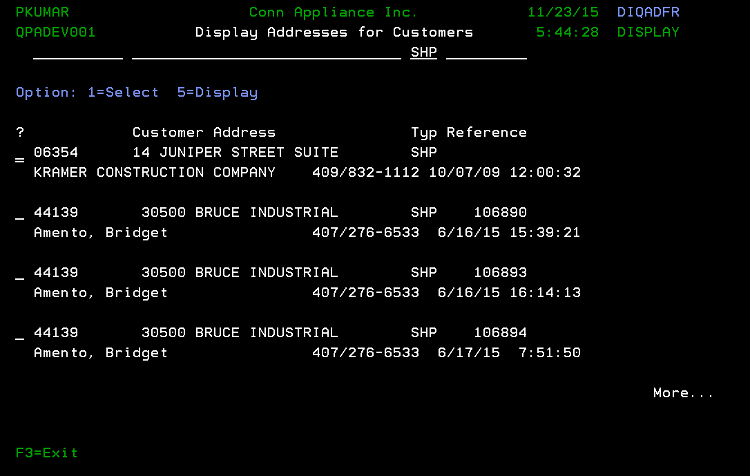

**Modernized UI:**

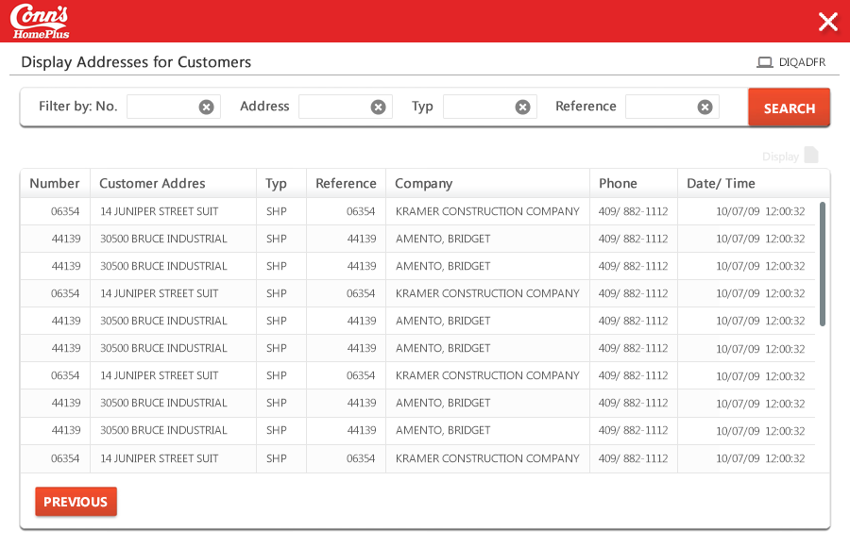

**Landing/ Entry points**

|  |  |  |  |  |
| --- | --- | --- | --- | --- |
| **Sr. No.** | **From Screen** | **Action** | **Parameters passed to this page** | **On load validations, Data Fetches** |
| 1 | Customer Addresses - DIMLDFR | Press “F10” |  |  |

**Function Keys**

|  |  |  |  |  |
| --- | --- | --- | --- | --- |
| **Sr. No.** | **Function Key** | **Column name (if applicable)** | **Goes to screen ID** | **Validation before going to another screen** |
| 1 | F3=Exit | NA | Customer Addresses - DIMLDFR | NA |
| 2 | 1=Select | NA | NA | NA |
| 3 | 5=Display | NA | NA | NA |

**List of Fields**

|  |  |  |  |  |
| --- | --- | --- | --- | --- |
| **Sr. No.** | **Column name** | **Tab Order** | **Validation** | **Backend Validation** |
| 1 | ? | Start | Should not be blank use option value  Only allowed values shall be entered |  |

# Screen ID: DST1DFR

**Screen Name** :Display Whse Comments

**AS/400 Screen shot:**

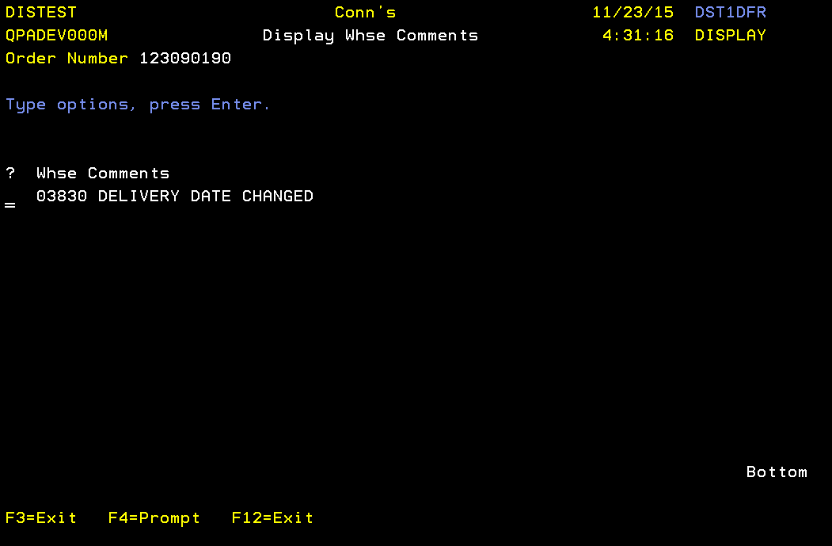

**Modernized UI:**

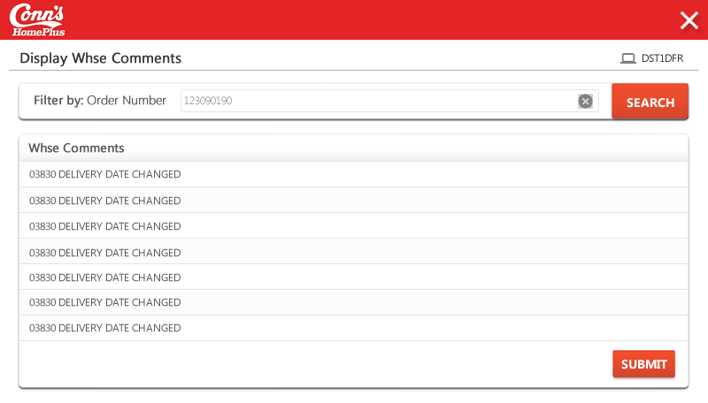

**Landing/ Entry points**

|  |  |  |  |  |
| --- | --- | --- | --- | --- |
| **Sr. No.** | **From Screen** | **Action** | **Parameters passed to this page** | **On load validations, Data Fetches** |
| 1 | Display Order Header Data - DSNJDTR | Press “F5” | Order Number |  |

**Function Keys**

| **Sr. No.** | **Function Key** | **Column name (if applicable)** | **Goes to screen ID** | **Validation before going to another screen** |
| --- | --- | --- | --- | --- |
| 1 | F4=Prompt | NA | NA | NA |
| 2 | F3=Exit | NA | Display Order Header Data - DSNJDTR | NA |
| 3 | F12=Exit | NA | Display Order Header Data - DSNJDTR | NA |

# Screen ID: DSHFETR

**Screen Name**: Edit Customer Notes - CU: ETR Customer Comments Edit transaction - Edit Customer Notes

**AS/400 Screen shot:**

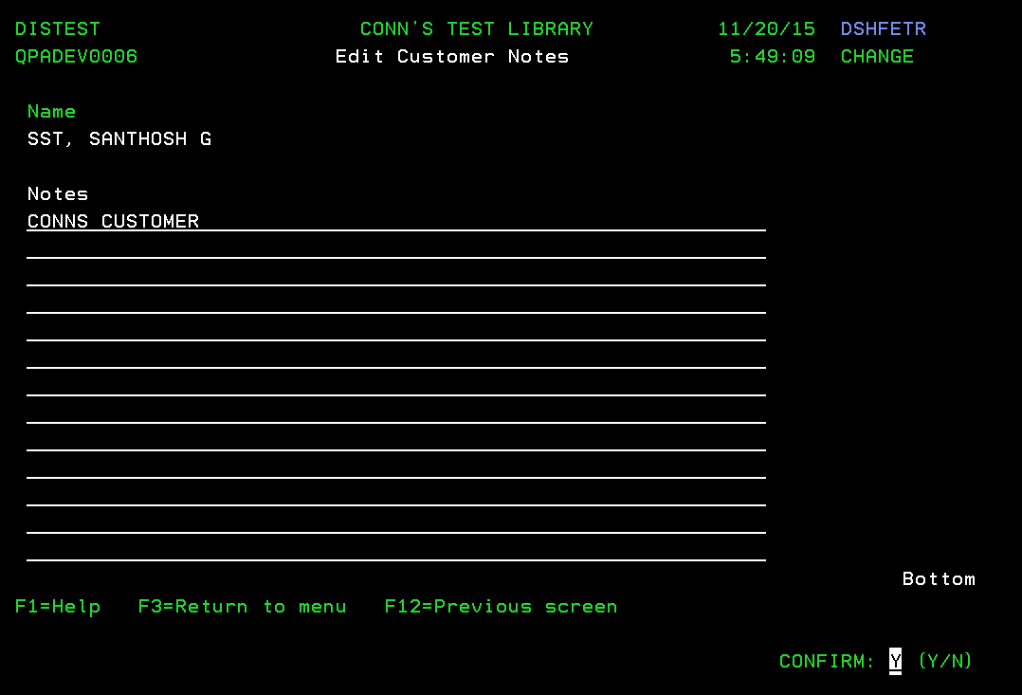

**Modernized UI:**

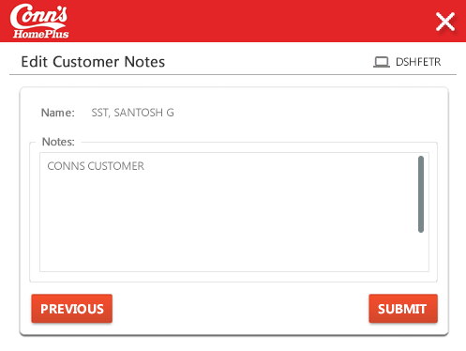

**Landing/ Entry points**

|  |  |  |  |  |
| --- | --- | --- | --- | --- |
| **Sr. No.** | **From Screen** | **Action** | **Parameters passed to this page** | **On load validations, Data Fetches** |
| 1 | Edit Customer Details - DSIME1R | Press “F8” | Customer Name |  |

**Function Keys**

|  |  |  |  |  |
| --- | --- | --- | --- | --- |
| **Sr. No.** | **Function Key** | **Column name (if applicable)** | **Goes to screen ID** | **Validation before going to another screen** |
| 1 | F1=Help | NA | ETR Customer Comments - YDDSHPR0 | NA |
| 2 | F3=Return to menu | NA | Menu Option Screen | NA |
| 3 | F12=Previous screen | NA | Display Customer - DSBPDFR | NA |
| 4 | Enter Key | NA | Saves the data entered after confirm prompt |  |
| 5 | F5=Refresh | NA | NA |  |

# Screen ID: DSRBDFR

**Screen Name**: Display Phone Number - CU: DSW Phone Numbers Display file - Display Phone Number

**AS/400 Screen shot:**

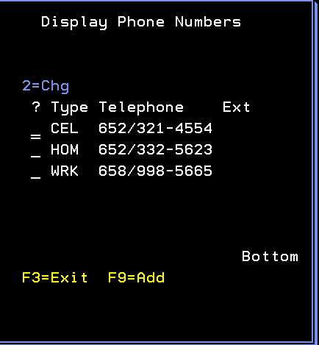

**Modernized UI:**

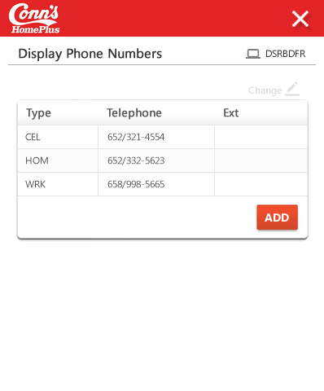

**Landing/ Entry points**

|  |  |  |  |  |
| --- | --- | --- | --- | --- |
| **Sr. No.** | **From Screen** | **Action** | **Parameters passed to this page** | **On load validations, Data Fetches** |
| 1 | Edit Customer Details - DSB9E1R | Press “F9” | Phone numbers already listed |  |

**Function Keys**

| **Sr. No.** | **Function Key** | **Column name (if applicable)** | **Goes to screen ID** | **Validation before going to another screen** |
| --- | --- | --- | --- | --- |
| 1 | F3=Exit | NA | Edit Customer Details - DSIME1R | NA |
| 2 | F9=Add | NA | Enter Phone Number Type - DSQ0E1R |  |
| 3 | 2=Chg | ? | Enter Phone Number - DSQ0E1R |  |

**List of Fields**

|  |  |  |  |  |
| --- | --- | --- | --- | --- |
| **Sr. No.** | **Column name** | **Tab Order** | **Validation** | **Backend Validation** |
| 1 | ? | Start | Only “2” is allowed to be entered |  |
| 2 | Type, Telephone, Ext |  | Display the type , telephone and Ext Numbers. |  |

# Screen ID: DSQ0E1R

**Screen Name**: Enter Phone Number Type

**AS/400 Screen shot:**

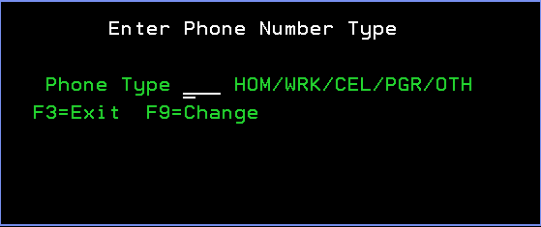

**Modernized UI:**

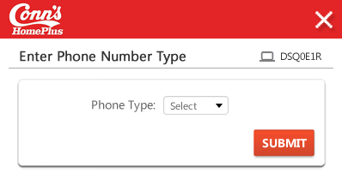

**Landing/ Entry points**

|  |  |  |  |  |
| --- | --- | --- | --- | --- |
| **Sr. No.** | **From Screen** | **Action** | **Parameters passed to this page** | **On load validations, Data Fetches** |
| 1 | Display Phone Number - DSRBDFR | Press “F9” | NA |  |

**Function Keys**

|  |  |  |  |  |
| --- | --- | --- | --- | --- |
| **Sr. No.** | **Function Key** | **Column name (if applicable)** | **Goes to screen ID** | **Validation before going to another screen** |
| 1 | F3=Exit | NA | Display Phone Numbers – DSRBDFR | NA |
| 2 | F9 = ADD | NA | Enter Phone Number - DSQ0E1R.  We can able to change the existing phone Number |  |
| 3 | F9 = Change | NA | Enter Phone Number - DSQ0E1R.  We can able to add the new phone Number with New Phone Number Type. |  |

# Screen ID: DSCZE1R

**Screen Name**: Edit Tax Exempt ID - CU: ER1 Tax Exempt Edit record(1 screen) - Edit Tax Exempt ID

**AS/400 Screen shot:**

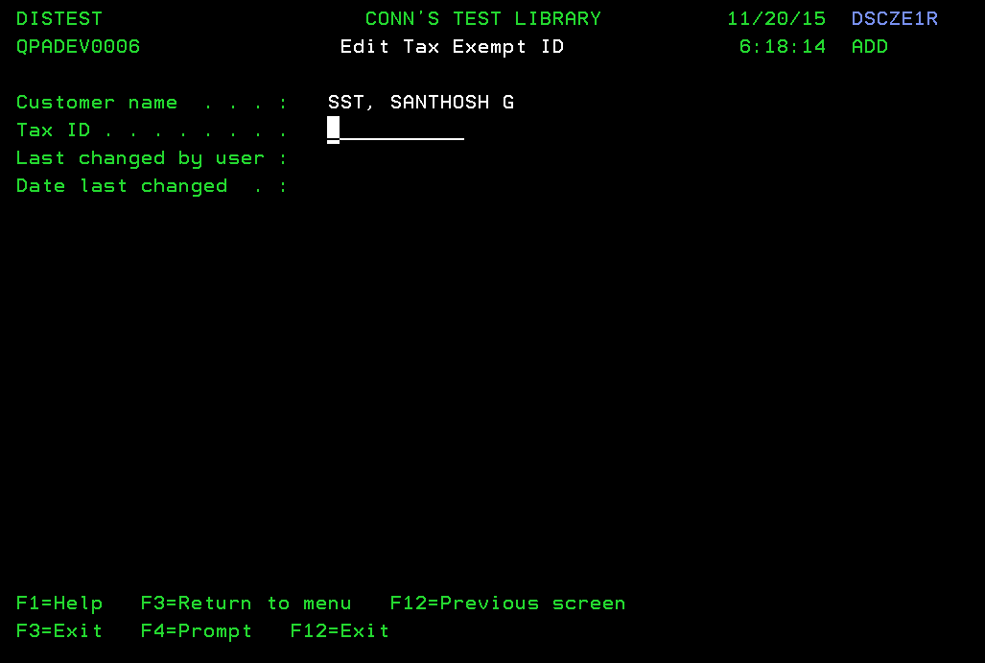

**Modernized UI:**

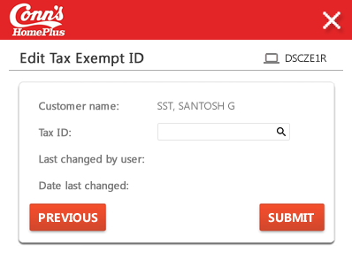

**Landing/ Entry points**

| Sr. No. | From Screen | Action | Parameters passed to this page | On load validations, Data Fetches |
| --- | --- | --- | --- | --- |
|  | DSIME1R – Edit Customer Details. | Hit F10=TaxID, and Confirm=’Y’ | N.A. |  |
|  | Display Customer Details - DSC7D1R | Hit F10=TaxID, and Confirm=’Y’ |  |  |

**Function Keys**

|  |  |  |  |  |
| --- | --- | --- | --- | --- |
| Sr. No. | Function Key | Column name (if applicable) | Goes to screen Id | Validation before going to another screen |
|  | F3=Exit | NA | Menu Option | NA |
|  | F12=Exit | NA | DSBPDFR – Display Customer | N.A |
|  | F4=Prompt | N.A | NA |  |
|  | F1=Help | N.A | DSCZE1R – Help Text Document CU: ER1 Tax Exempt | N.A |
|  | F3=Return to menu | N.A | Menu Option | NA |
|  | F12=Previous screen | N.A | DSBPDFR – Display Customer | N.A |

**List of Fields**

|  |  |  |  |  |
| --- | --- | --- | --- | --- |
| Sr. No. | Column name | Tab Order | Validation | Backend Validation |
|  | Tax ID |  | Should not be blank entered. Both Character and Numeric allowed. |  |

# Screen ID: DIO2PVR

**Screen Name**: SY: Addressing Info

**AS/400 Screen shot:**



**Modernized UI:**

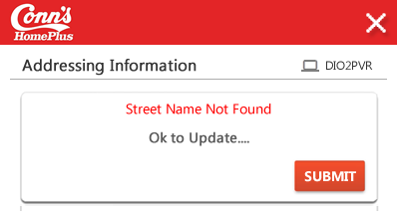

**Landing/ Entry points**

|  |  |  |  |  |
| --- | --- | --- | --- | --- |
| **Sr. No.** | **From Screen** | **Action** | **Parameters passed to this page** | **On load validations, Data Fetches** |
| 1 | Edit Customer Details - DSIME1R | Leave the Zip Code field as Blank and Press enter. It will ask to update the Insufficient City/State/Zip Information. | NA |  |

# Screen ID: DIMMPVR

**Screen Name**: CO: Employee

**AS/400 Screen shot:**

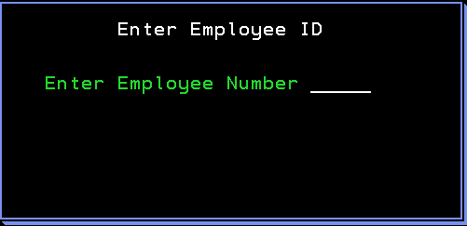

**Modernized UI:**

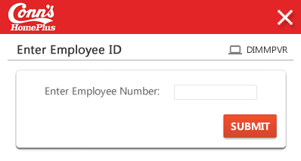

**Landing/ Entry points**

|  |  |  |  |  |
| --- | --- | --- | --- | --- |
| **Sr. No.** | **Frame Screen** | **Action** | **Parameters passed to this page** | **On load validations, Data Fetches** |
| 1 | Addressing Information - DIO2PVR | Choose any of the options in the screen and press “Enter” key |  |  |

**List of Fields**

|  |  |  |  |  |
| --- | --- | --- | --- | --- |
| **Sr. No.** | **Column name** | **Tab Order** | **Validation** | **Backend Validation** |
| 1 | Employee Number | NA | Should not be blank entered numeric value  Only allowed values shall be entered |  |

# Screen ID: DSB9E1R

**Screen Name**: Edit Customer Details(New Customer)

**AS/400 Screen shot:**

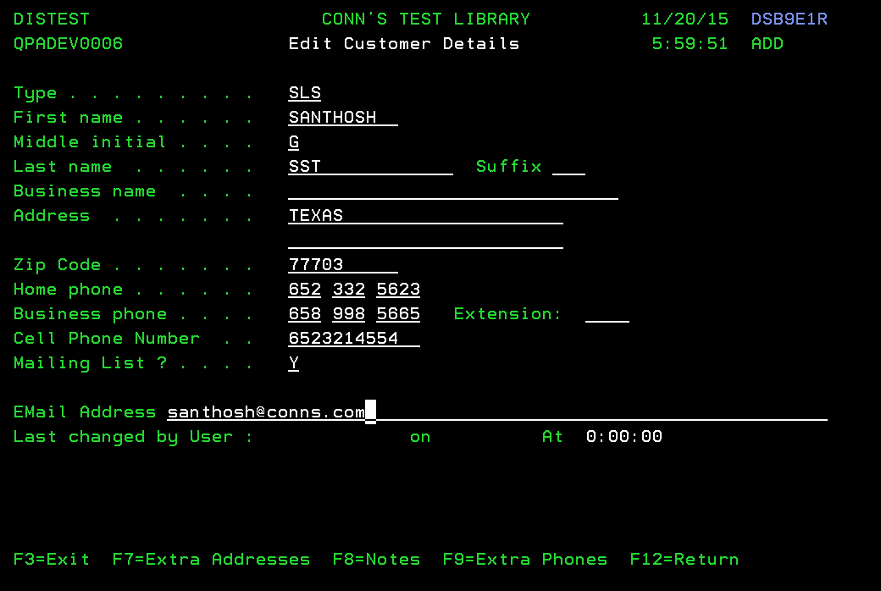

**Modernized UI:**

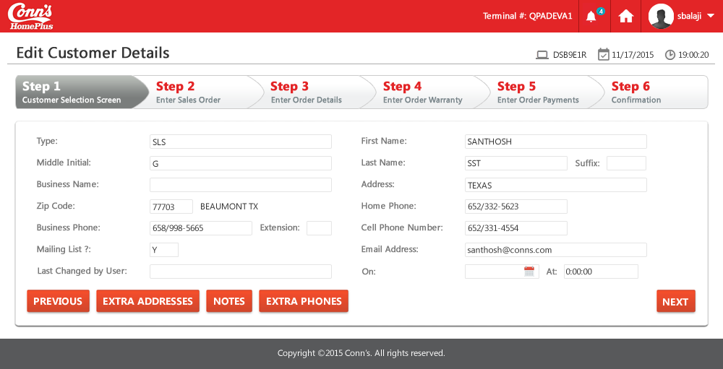

**Landing/ Entry points**

|  |  |  |  |  |
| --- | --- | --- | --- | --- |
| **Sr. No.** | **From Screen** | **Action** | **Parameters passed to this page** | **On load validations, Data Fetches** |
| 1 | Prompt to Find Customer -  CCCMPVI | Press F3 or Enter. |  |  |
| 2. | CCHXE1R - Edit Customer Details | Hit F7 Option |  |  |

**Function Keys**

|  |  |  |  |  |
| --- | --- | --- | --- | --- |
| **Sr. No.** | **Function Key** | **Column name (if applicable)** | **Goes to screen ID** | **Validation before going to another screen** |
| 1 | F3=Exit | NA | Menu Option | NA |
| 2 | F7=Extra Address | NA | Customer Addresses - DIMLDFR |  |
| 3 | F8=Notes | NA | Edit Customer Notes - DSHFETR |  |
| 4 | F9=Extra Phones |  |  |  |
| 5 | F12=Return |  |  |  |
| 6 | F4=Prompt | Type | Display Allowed Values - Y2VLLSR |  |
| 7 | F4=Prompt | Mailing List | Display Allowed Values - Y2VLLSR |  |
| 8 | Prompt (?) | Zip Code | DSBESRR - Select Zip Code |  |

**List of Fields**

|  |  |  |  |  |
| --- | --- | --- | --- | --- |
| Sr. No. | Column name | Tab Order | Validation | Backend Validation |
|  | Type | Start | Should be in the list prompted. |  |
|  | First Name | 2 | Should not be blank |  |
|  | Middle Initial | 3 | Its not a mandatory. |  |
|  | Last Name | 4 | Should not be blank |  |
|  | Suffix | 5 | Its not a mandatory. |  |
|  | Business Name | 6 | Its not a mandatory. |  |
|  | Address Line1 | 7 | Should not be blank |  |
|  | Address Line2 | 8 | Its not a mandatory. |  |
|  | Zip Code | 9 | Should be in the list promted. |  |
|  | Home Phone | 10, 11, 12 | Should be numeric only. And all three tab filled. |  |
|  | Business Phone | 13, 14, 15 | Should be numeric only. |  |
|  | Extension | 16 | Should be numeric only. |  |
| 1. C | Cell Phone Number | 17 | Should be numeric only. |  |
|  | Mailing List | 18 | Should be in the list prompted. |  |
|  | Email Address | 19 | Should be able to type any characters in the field. But the results should be displayed only if the entire email id is entered. |  |

# Screen ID: DIJVPVR

**Screen Name**: Customer ID Card Entry on DSC4PVR (F7) - SY: PMW Scan Input 07 Prompt &validate record - Swipe or Enter Number

**AS/400 Screen shot:**



**Modernized UI:**

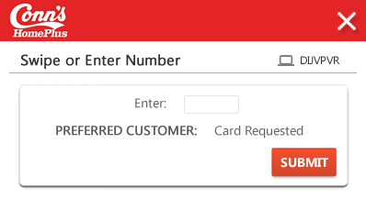

**Landing/ Entry points**

|  |  |  |  |  |
| --- | --- | --- | --- | --- |
| Sr. No. | From Screen | Action | Parameters passed to this page | On load validations, Data Fetches |
|  | DSC4PVR – Customer Selection Screen | Hit F7. |  |  |

**Function Keys**

|  |  |  |  |  |
| --- | --- | --- | --- | --- |
| **Sr. No.** | **Function Key** | **Column name (if applicable)** | **Goes to screen ID** | **Validation before going to another screen** |
| 1 | F3=Exit | NA | DSC4PVR – Customer Selection Screen | NA |
| 2 | F12=Previous | NA | DSC4PVR – Customer Selection Screen | N.A |

**List of Fields**

|  |  |  |  |  |
| --- | --- | --- | --- | --- |
| Sr. No. | Column name | Tab Order | Validation | Backend Validation |
|  | Enter Number | Start | Can be any character |  |

# Screen ID: CCCMPVI

**Screen Name:** Customer prompt & Validate record (SSN) - CA: PMT Test 4 Customer Prompt & validate record

**AS/400 Screen shot:**

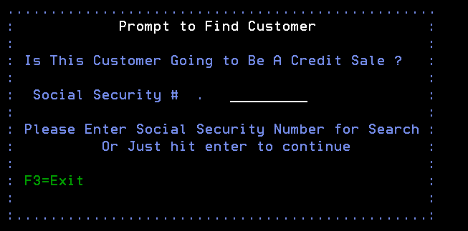

**Modernized UI:**

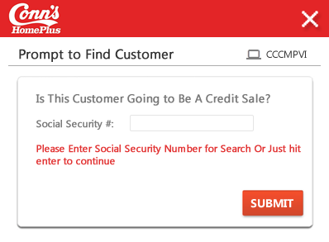

**Landing/ Entry points**

|  |  |  |  |  |
| --- | --- | --- | --- | --- |
| **Sr. No.** | **From Screen** | **Action** | **Parameters passed to this page** | **On load validations, Data Fetches** |
| 1 | Customer Selection Screen - DSC4PVR | Press “F6” | NA | NA |

**Function Keys**

|  |  |  |  |  |
| --- | --- | --- | --- | --- |
| **Sr. No.** | **Function Key** | **Column name (if applicable)** | **Goes to screen ID** | **Validation before going to another screen** |
| 1 | F3=Exit | NA | Edit Customer Details - DSB9E1R |  |
| 2 | F12=Return | NA | Edit Customer Details - DSB9E1R |  |

**List of Fields**

|  |  |  |  |  |
| --- | --- | --- | --- | --- |
| Sr. No. | Column name | Tab Order | Validation | Backend Validation |
|  | Social Security No. | Start | Can be numeric 1- 9 |  |

# Screen ID: CAB6D1R

**Screen Name:** CU: Customer SSN Validate

**AS/400 Screen shot:**

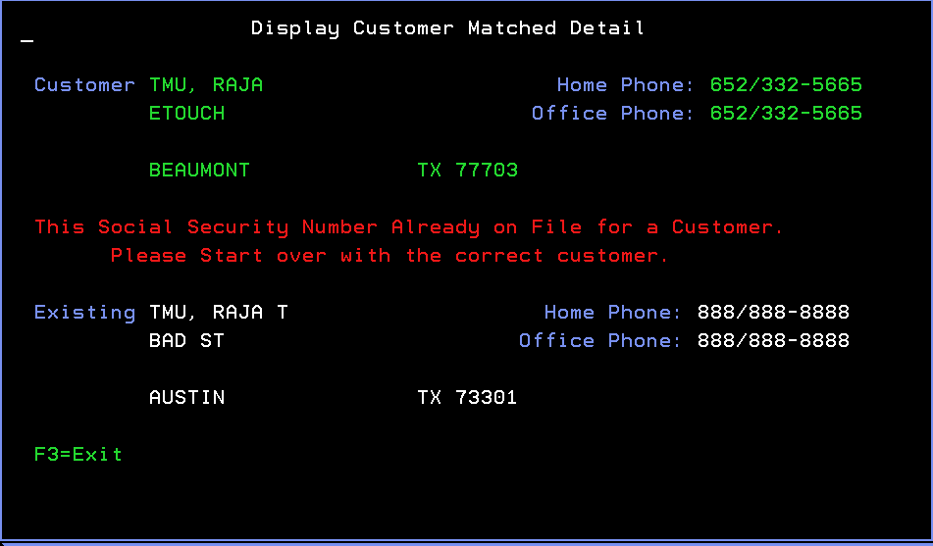

**Modernized UI:**

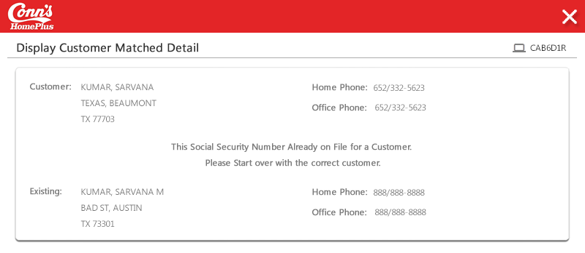

**Landing/ Entry points**

|  |  |  |  |  |
| --- | --- | --- | --- | --- |
| Sr. No. | From Screen | Action | Parameters passed to this page | On load validations, Data Fetches |
|  | CCHXE1R - Edit Personal Details | Hit Enter | N.A. |  |

**Function Keys**

|  |  |  |  |  |
| --- | --- | --- | --- | --- |
| Sr. No. | Function Key | Column name (if applicable) | Goes to screen Id | Validation before going to another screen |
|  | F3=Exit | NA | DSEBETR - Enter Order Payments | NA |
|  | F12=Previous | NA | DSEBETR - Enter Order Payments | NA |

**List of Fields**

-- None –

# Screen ID: DSVFDFR

**Screen Name:** Display Customer

**AS/400 Screen shot:**

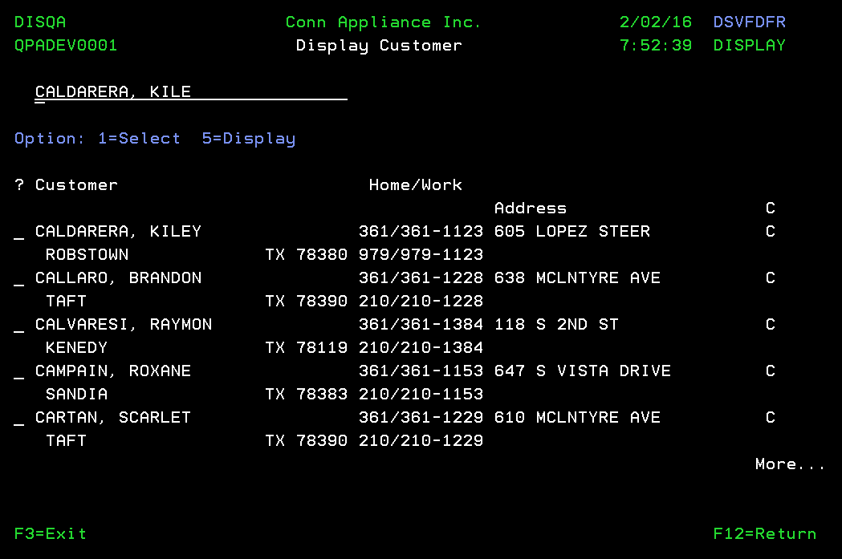

**Modernized UI:**

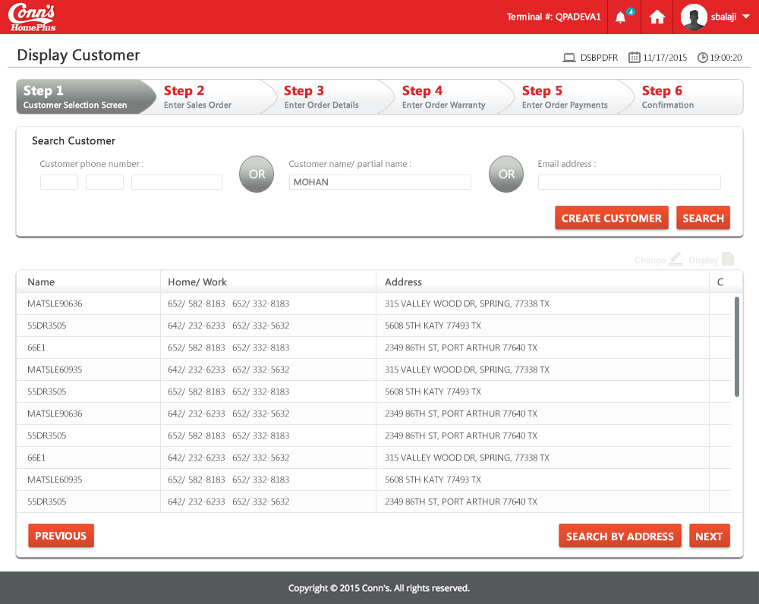

**Landing/ Entry points**

|  |  |  |  |  |
| --- | --- | --- | --- | --- |
| **Sr. No.** | **From Screen** | **Action** | **Parameters passed to this page** | **On load validations, Data Fetches** |
| 1 | Select Customer/Order **-** DSZGPVR | Enter the customer name | Search string (Name of customer) |  |

**Function Keys**

|  |  |  |  |  |
| --- | --- | --- | --- | --- |
| **Sr. No.** | **Function Key** | **Column name (if applicable)** | **Goes to screen ID** | **Validation before going to another screen** |
| 1 | F3=Exit | NA | Salesman Menu | NA |
| 2 | F12=Return | NA | Select Customer/Order **-** DSZGPVR |  |
| 3 | 1=Select | ? | Select Customer Orders - DSHQDFR |  |
| 4 | 5=Display | ? | Display Customer Details - DSC7D1R |  |

**List of Fields**

|  |  |  |  |  |
| --- | --- | --- | --- | --- |
| **Sr. No.** | **Column name** | **Tab Order** | **Validation** | **Backend Validation** |
| 1 | “Customer Name” filter | Start | Can enter any character |  |
| 2 | ? | 2 | Can enter “1” or “5” |  |

# Screen ID: DSU5DTR

**Screen Name:** Select Completed Order Header

**AS/400 Screen shot:**

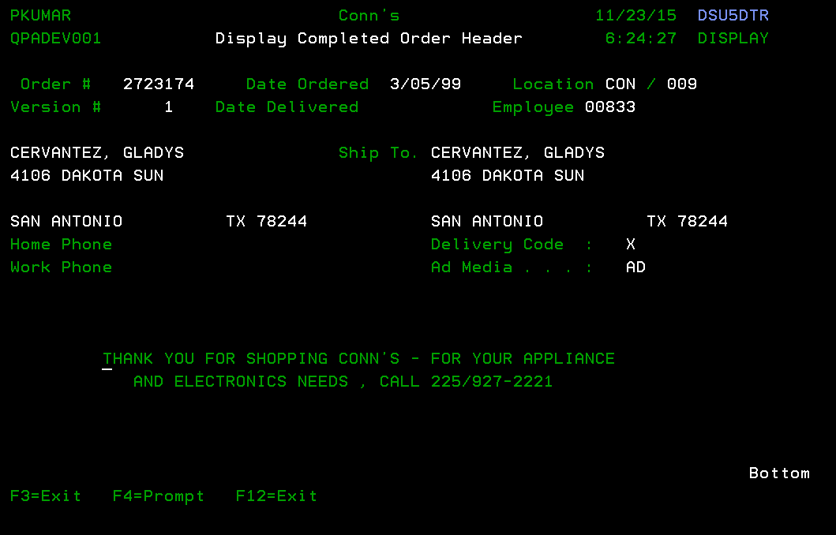

**Modernized UI:**

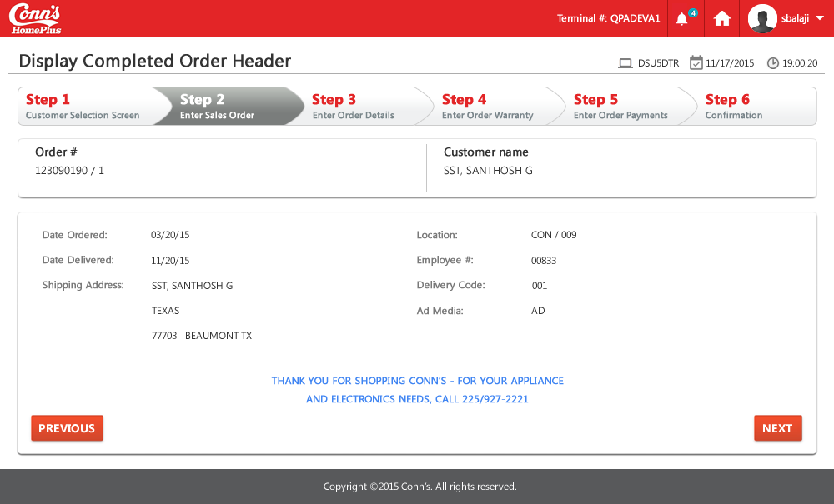

**Landing/ Entry points**

|  |  |  |  |  |
| --- | --- | --- | --- | --- |
| Sr. No. | From Screen | Action | Parameters passed to this page | On load validations, Data Fetches |
|  | DIMLDFR - Customer Addresses | Select option 5 against Order type “ORD” | N.A |  |

**Function Keys**

|  |  |  |  |  |
| --- | --- | --- | --- | --- |
| Sr. No. | Function Key | Column name (if applicable) | Goes to screen Id | Validation before going to another screen |
|  | F3=Exit | N.A | DIMLDFR - Customer Addresses |  |
|  | F4=Prompt | N.A |  |  |
|  | F12=Previous | N.A | DIMLDFR - Customer Addresses |  |

**List of Fields**

-- None –

# Screen ID: CCJ0PVR

**Screen Name:** Submit to Credit for Review

**AS/400 Screen shot:**

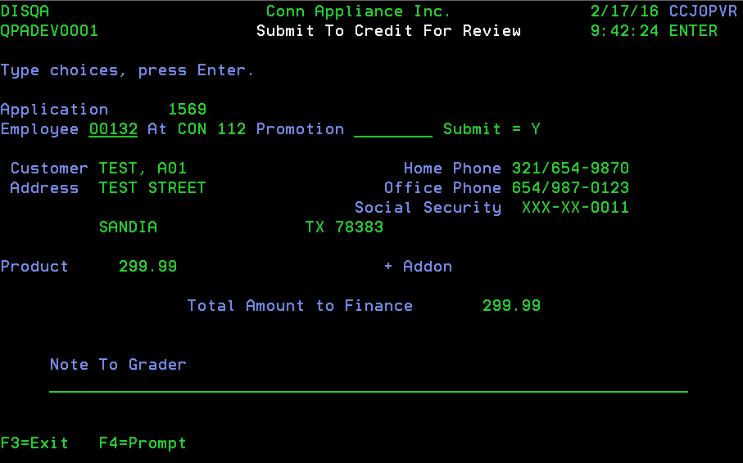

**Landing/ Entry points**

|  |  |  |  |  |
| --- | --- | --- | --- | --- |
| **Sl. No.** | **From Screen** | **Action** | **Parameters passed to this page** | **On load validations, Data Fetches** |
| 1 | Prompt for Credit Application Entry - DSEBETR | Press “F9=Enter Application ” | NA |  |

**Function Keys**

| **Sl. No.** | **Function Key** | **Column name (if applicable)** | **Goes to screen ID** | **Validation before going to another screen** |
| --- | --- | --- | --- | --- |
| 1 | F3=Exit | NA | CCLVD1R - Display Application Status |  |
| 2 | F4=Prompt | NA | NA |  |

**List of Fields**

|  |  |  |  |  |
| --- | --- | --- | --- | --- |
| **Sl. No.** | **Column name** | **Tab Order** | **Validation** | **Backend Validation** |
| 1 | Employee | 1 | Only allowed valid employee Id |  |
| 2 | Promotion | 2 | Allows both numbers and alphabets |  |
| 3 | Note To Grader | 3 | Allows both numbers and alphabets |  |

# Screen ID: CCHXE1R

**Screen Name:** Edit Personal Details

**AS/400 Screen shot:**

Screen 1:

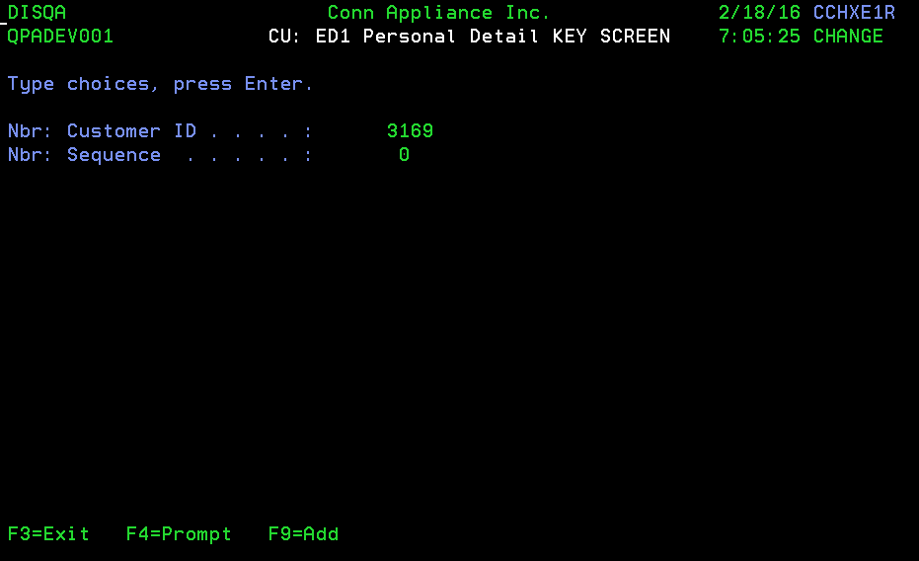

**Landing/ Entry points**

|  |  |  |  |  |
| --- | --- | --- | --- | --- |
| **Sl. No.** | **From Screen** | **Action** | **Parameters passed to this page** | **On load validations, Data Fetches** |
| 1 | Prompt for Credit Application Entry - CCKFPVR | Take “F9=Enter Application” | NA |  |

**Function Keys**

| **Sl. No.** | **Function Key** | **Column name (if applicable)** | **Goes to screen ID** | **Validation before going to another screen** |
| --- | --- | --- | --- | --- |
| 1 | F3=Exit | NA | DSEBETR - Enter Order Payments |  |
| 2 | F4=Prompt | NA | NA |  |
| 3 | F9=Add | NA | NA |  |

**List of Fields**

-- None –

Screen2:

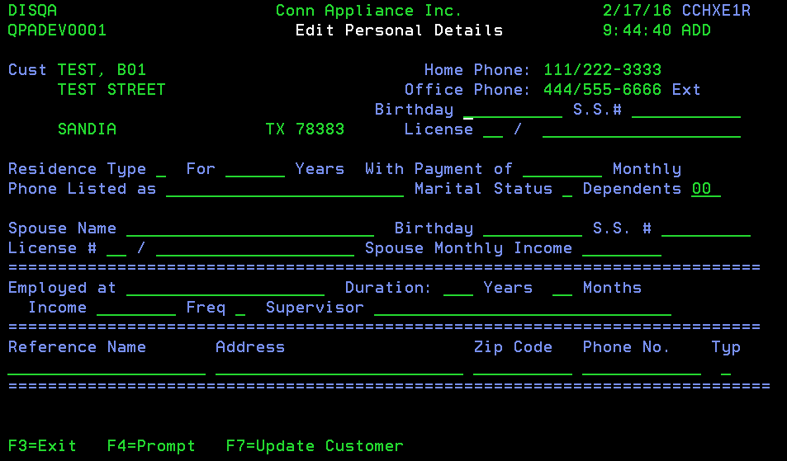

**Landing/ Entry points**

|  |  |  |  |  |
| --- | --- | --- | --- | --- |
| **Sl. No.** | **From Screen** | **Action** | **Parameters passed to this page** | **On load validations, Data Fetches** |
| 1 | Prompt for Credit Application Entry - DSEBETR | Press “F9=Enter Application ” | NA |  |

**Function Keys**

| **Sl. No.** | **Function Key** | **Column name (if applicable)** | **Goes to screen ID** | **Validation before going to another screen** |
| --- | --- | --- | --- | --- |
| 1 | F3=Exit | NA | CCLVD1R - Display Application Status |  |
| 2 | F4=Prompt | Residence Type | CCVLLSR - Display Allowed Values - Cde: Residence Type |  |
| 3 | F4=Prompt | Marital Status | CCVLLSR - Display Allowed Values - Sts: Marital |  |
| 4 | F4=Prompt | Freq | CCVLLSR - Display Allowed Values - Cde: Income Frequency |  |
| 5 | F4=Prompt | Typ | CCVLLSR - Display Allowed Values - Sts: Reference Type |  |
| 6 | F7=Update Customer | NA | DSB9E1R - Edit Customer Details |  |

**List of Fields**

|  |  |  |  |  |
| --- | --- | --- | --- | --- |
| **Sl. No.** | **Column name** | **Tab Order** | **Validation** | **Backend Validation** |
| 1 | Birthday | Start | Only allowed values can be used. Mandatory field |  |
| 2 | S.S.# | 2 | Only allowed values can be used. Mandatory field |  |
| 3 | License | 3 | Allows both numbers and alphabets. Mandatory field |  |
| 4 | Residence Type | 4 | Only allowed values shall be entered (*BLANK, L, O, R) |  |
| 5 | For | 5 | Allows numbers Only |  |
| 6 | With Payment of | 6 | Allows numbers Only |  |
| 7 | Phone Listed as | 7 | Allows both numbers and alphabets |  |
| 8 | Marital Status | 8 | Only allowed values shall be entered (*BLANK, M, S) |  |
| 9 | Dependents | 9 | Allows numbers Only |  |
| 10 | Spouse Name | 10 | Allows both numbers and alphabets |  |
| 11 | Birthday | 11 | Allows numbers Only |  |
| 12 | S.S. # | 12 | Allows numbers Only |  |
| 13 | License # | 13 | Allows both numbers and alphabets |  |
| 14 | Spouse Monthly Income | 14 | Allows numbers Only |  |
| 15 | Employed at | 15 | Allows both numbers and alphabets. Mandatory field |  |
| 16 | Duration - Years | 16 | Allows numbers Only |  |
| 17 | Duration - Months | 17 | Allows numbers Only |  |
| 18 | Income | 18 | Allows numbers. Mandatory field |  |
| 19 | Freq | 19 | Only allowed values shall be entered (*BLANK, A, B, H, M, W ), Mandatory field |  |
| 20 | Supervisor | 20 | Allows both numbers and alphabets |  |
| 21 | Reference Name | 21 | Allows both numbers and alphabets |  |
| 22 | Address | 22 | Allows both numbers and alphabets |  |
| 23 | Zip Code | 23 | Allows both numbers and alphabets |  |
| 24 | Phone No | 24 | Allows numbers Only |  |
| 25 | Typ | 25 | Only allowed values shall be entered (*BLANK, F, R) |  |

# 

# Screen ID: DSM1DFR

**Screen Name:** PO: Purchase Order Detail

**AS/400 Screen shot:**

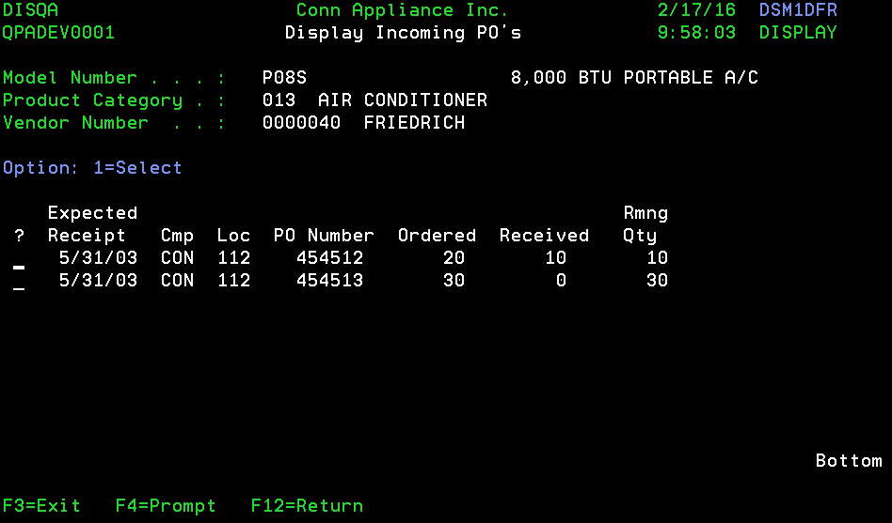

**Landing/ Entry points**

|  |  |  |  |  |
| --- | --- | --- | --- | --- |
| **Sl. No.** | **From Screen** | **Action** | **Parameters passed to this page** | **On load validations, Data Fetches** |
| 1 | Display Inventory for Reserve - DSM7DFR | Take option “7=Orders” | NA |  |

**Function Keys**

| **Sl. No.** | **Function Key** | **Column name (if applicable)** | **Goes to screen ID** | **Validation before going to another screen** |
| --- | --- | --- | --- | --- |
| 1 | F3=Exit | NA | DSFMETR - Enter Order Detail |  |
| 2 | F4=Prompt | NA | NA |  |
| 3 | F12=Return | NA | DSM7DFR - Display Inventory for Reserve |  |
| 4 | 1 | ? | DSFMETR - Enter Order Detail |  |

**List of Fields**

|  |  |  |  |  |
| --- | --- | --- | --- | --- |
| **Sl. No.** | **Column name** | **Tab Order** | **Validation** | **Backend Validation** |
| 1 | ? | Start | Allows “1=Select” |  |

# Screen ID: DIG2DFR

**Screen Name:** IN: SKU Family

**AS/400 Screen shot:**

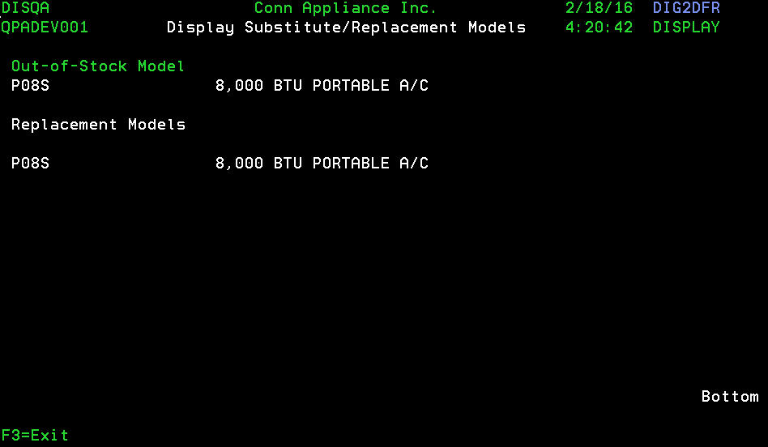

**Landing/ Entry points**

|  |  |  |  |  |
| --- | --- | --- | --- | --- |
| **Sl. No.** | **From Screen** | **Action** | **Parameters passed to this page** | **On load validations, Data Fetches** |
| 1 | Model Inquiry - DSWXDFR | Take option “7=Sub/Rpl Models” | NA |  |

**Function Keys**

| **Sl. No.** | **Function Key** | **Column name (if applicable)** | **Goes to screen ID** | **Validation before going to another screen** |
| --- | --- | --- | --- | --- |
| 1 | F3=Exit | NA | DSWXDFR - Model Inquiry |  |

**List of Fields**

-- None --

# Screen ID: DIGFE1R

**Screen Name:** CU: Customer

## AS/400 Screen shot:

Screen1:

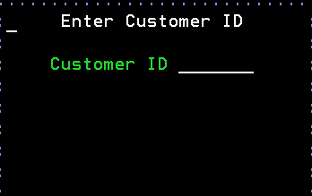

Landing/ Entry points

|  |  |  |  |  |
| --- | --- | --- | --- | --- |
| **Sl. No.** | **From Screen** | **Action** | **Parameters passed to this page** | **On load validations, Data Fetches** |
| 1 | Prompt for Credit Application Entry - CCKFPVR | Press “F9=Enter Application ” | NA |  |

### Function Keys

| **Sl. No.** | **Function Key** | **Column name (if applicable)** | **Goes to screen ID** | **Validation before going to another screen** |
| --- | --- | --- | --- | --- |
| 1 | F3=Exit | NA | DSEBETR - Enter Order Payments |  |
| 2 | F12=Exit | NA | DSEBETR - Enter Order Payments |  |
| 3 | Enter | NA | DIGFE1R - Edit Customer Information |  |

### List of Fields

|  |  |  |  |  |
| --- | --- | --- | --- | --- |
| **Sl. No.** | **Column name** | **Tab Order** | **Validation** | **Backend Validation** |
| 1 | Customer Id | Start | Allows both numbers and alphabets. Mandatory field |  |

Screen2:

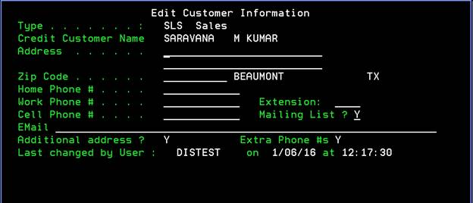

Landing/ Entry points

|  |  |  |  |  |
| --- | --- | --- | --- | --- |
| **Sl. No.** | **From Screen** | **Action** | **Parameters passed to this page** | **On load validations, Data Fetches** |
| 1 | Prompt for Credit Application Entry - DSEBETR | Press “F9=Enter Application ” | NA |  |

### Function Keys

| **Sl. No.** | **Function Key** | **Column name (if applicable)** | **Goes to screen ID** | **Validation before going to another screen** |
| --- | --- | --- | --- | --- |
| 1 | F3=Exit | NA | CCLVD1R - Display Application Status |  |
| 2 | Prompt (?) | Zip Code | DSBESRR - Select Zip Code |  |
| 3 | F4 = Prompt | Mailing List | Y2VLLWR - # Status: 1 list |  |
| 4 | F7 | NA | DIMLDFR - Customer Addresses |  |
| 5 | F8 | NA | DSHFETR - Edit Customer Notes |  |
| 6 | F9 | NA | DSRBDFR - Display Phone Numbers |  |

### List of Fields

|  |  |  |  |  |
| --- | --- | --- | --- | --- |
| **Sl. No.** | **Column name** | **Tab Order** | **Validation** | **Backend Validation** |
| 1 | Address | Start | Allows both numbers and alphabets. Mandatory field |  |
| 2 | Zip Code | 1 | Allows both numbers and alphabets. Mandatory field |  |
| 3 | Home Phone # | 2 | Allows numbers. Mandatory field |  |
| 4 | Work Phone # | 3 | Allows numbers. Mandatory field |  |
| 5 | Extension | 4 | Allows numbers. |  |
| 6 | Cell Phone # | 5 | Allows numbers. Mandatory field |  |
| 7 | Mailing List | 6 | Only allowed values shall be entered (*BLANK, Y, 0, 1, 2,3, 4, 5 ). Mandatory field |  |
| 8 | EMail | 7 | Allows both numbers and alphabets |  |

# Screen ID: CCGIDFI

**Screen Name:** CA: DFI Crd Cmp Message Display file

## AS/400 Screen shot:

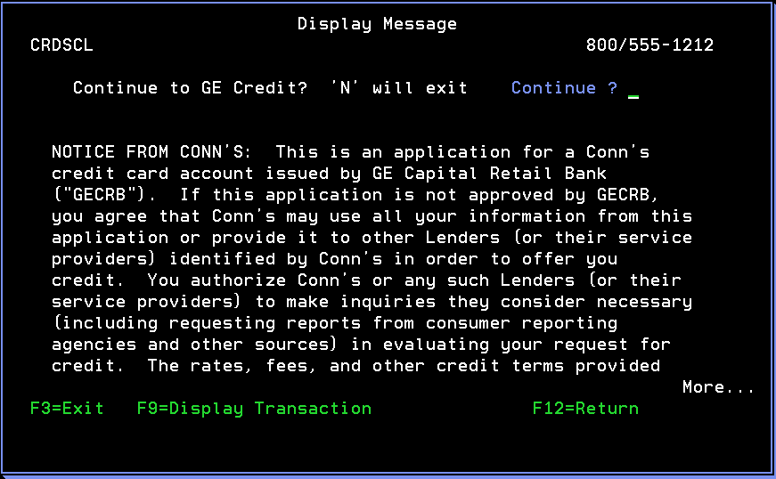

Landing/ Entry points

|  |  |  |  |  |
| --- | --- | --- | --- | --- |
| **Sl. No.** | **From Screen** | **Action** | **Parameters passed to this page** | **On load validations, Data Fetches** |
| 1 | Edit Personal Details - CCHXE1R | Hit Enter | NA |  |

### Function Keys

| **Sl. No.** | **Function Key** | **Column name (if applicable)** | **Goes to screen ID** | **Validation before going to another screen** |
| --- | --- | --- | --- | --- |
| 1 | F3=Exit | NA | CCGIDFI - Display Message |  |
| 2 | F9=Display Transaction | NA | CCGCD1I - CU: D1I Ext Crd Tran KEY SCREEN |  |
| 3 | F12=Return | NA | CCGIDFI - Display Message |  |

### List of Fields

|  |  |  |  |  |
| --- | --- | --- | --- | --- |
| **Sl. No.** | **Column name** | **Tab Order** | **Validation** | **Backend Validation** |
| 1 | Continue | Start | Only allow *BLANK, N, Y |  |

# Screen ID: CCGCD1I

**Screen Name:** CUL D1I Ext Crd Tran Display record

## AS/400 Screen shot:

Screen1:

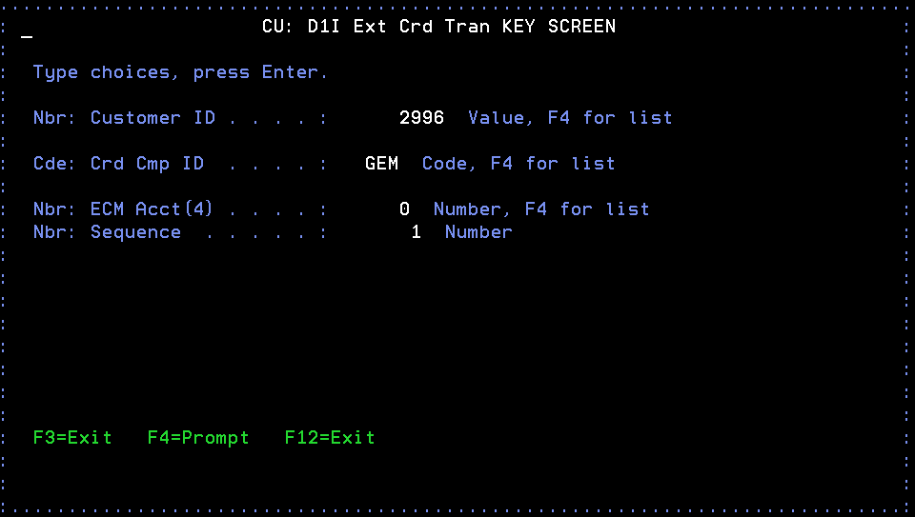

Landing/ Entry points

|  |  |  |  |  |
| --- | --- | --- | --- | --- |
| **Sl. No.** | **From Screen** | **Action** | **Parameters passed to this page** | **On load validations, Data Fetches** |
| 1 | Display Message - CCGIDFI | Hit Enter | NA |  |

### Function Keys

| **Sl. No.** | **Function Key** | **Column name (if applicable)** | **Goes to screen ID** | **Validation before going to another screen** |
| --- | --- | --- | --- | --- |
| 1 | F3=Exit | NA | CCGIDFI - Display Message |  |
| 2 | F4=Prompt | NA | NA |  |
| 3 | F12=Exit | NA | CCGIDFI - Display Message |  |

### List of Fields

-- None --

Screen2:

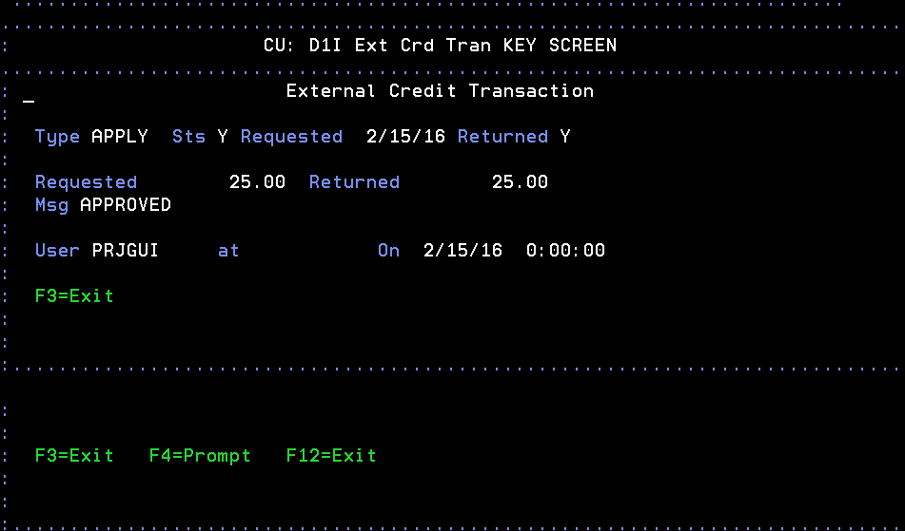

Landing/ Entry points

|  |  |  |  |  |
| --- | --- | --- | --- | --- |
| **Sl. No.** | **From Screen** | **Action** | **Parameters passed to this page** | **On load validations, Data Fetches** |
| 1 | CU: D1I Ext Crd Tran KEY SCREEN - CCGCD1I | Hit Enter | NA |  |

### Function Keys

| **Sl. No.** | **Function Key** | **Column name (if applicable)** | **Goes to screen ID** | **Validation before going to another screen** |
| --- | --- | --- | --- | --- |
| 1 | F3=Exit | NA | CCGIDFI - Display Message |  |
| 2 | F4=Prompt | NA | NA |  |
| 3 | F12=Exit | NA | CCGIDFI - Display Message |  |

### List of Fields

-- None --

# Screen ID: DSGQPVI

**Screen Name:** CU: PMT Spc Ship-to Cust Prompt & validate record

## AS/400 Screen shot:

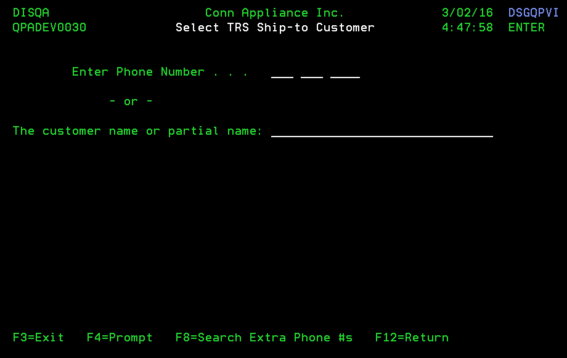

Landing/ Entry points

|  |  |  |  |  |
| --- | --- | --- | --- | --- |
| **Sl. No.** | **From Screen** | **Action** | **Parameters passed to this page** | **On load validations, Data Fetches** |
| 1 | DSBPDFR - Display Customer | Select 1 against a RAC customer and Hit Enter | NA |  |

### Function Keys

| **Sl. No.** | **Function Key** | **Column name (if applicable)** | **Goes to screen ID** | **Validation before going to another screen** |
| --- | --- | --- | --- | --- |
| 1 | F3=Exit | NA | Sales Menu - DSM003C |  |
| 2 | F4=Prompt | N.A | N.A |  |
| 3 | F8=Search Extra Phone #s | NA | DIBDDFR - Display Customer Phone Numbers |  |
| 4 | F12=Return | NA | Sales Menu - DSM003C |  |
| 5 | ‘?’ | The customer name or partial name | DSVFDFR - Display Customer |  |

### List of Fields

|  |  |  |  |  |
| --- | --- | --- | --- | --- |
| **Sl. No.** | **Column name** | **Tab Order** | **Validation** | **Backend Validation** |
| 1 | Enter Phone Number (3 sections like xxx-xxx-xxxx) | 1 The cursor by default would be on the 1st part of the phone number  2 On the 2nd hit, the cursor moves to the next part of phone number  3 On the 3rd hit of tab, the last part of phone number will have the cursor | Should be able to type only numeric values  All 10 digits should be filled |  |
| 2 | The customer name or partial name | 4 | Can support all character. |  |